**Pet Grooming Booking Mobile App**

**(Groomify)**

**By**

**DAMIEN TAN LEK KHEE**

**Being the project proposal submitted to**

**INTI INTERNATIONAL COLLEGE PENANG**

**as a requirement for**

**Bachelor of Science with Honours in Computer Science**

**Session APRIL 2023**

**School of Engineering and Technology**

**INTI INTERNATIONAL COLLEGE PENANG**

Table of Contents

List of Tables 3

List Of Figures 4

Chapter 1 5

Introduction 5

**1.1 Introduction** 5

**1.2 Problem Statement** 5

**1.3 Project Objectives** 6

**1.4 Detailed Research Question** 6

**1.5 Client, Audience, Motivation** 7

**1.5.1 Client** 7

**1.5.2 Audience** 7

**1.5.3 Motivation** 8

**1.6 Scope** 8

**1.7 Conclusion** 9

Chapter 2 10

Literature Review 10

**2.1 Introduction** 10

**2.2 Terminologies** 11

**2.3 Summary of Existing System** 12

**2.4 Features Derived to Groomify App** 17

**2.5 Comparison of Development Tools** 19

**2.5.1 Database** 19

**2.5.2 Programming Language** 27

**2.5.3 Operating System** 35

**2.5.4 Frameworks** 42

**2.5.5 Comparison of SDLCs** 49

**2.6 Conclusion** 54

Chapter 3 55

Research Methodology 55

**3.1 Introduction** 55

**3.2** 55

References 56

# **List of Tables**

Table 1: Comparison of Firebase, MongoDB & MySQL 26

Table 2: Comparison of Dart, Java & Kotlin 35

Table 3: Comparison of Android & IOS 41

Table 4: Comparison of Figma, XD & Sketch 49

Table 5: Comparisons of Waterfall, Spiral & Incremental Models 53

# **List Of Figures**

Figure 1: PetBacker App 12

Figure 2: Service Providers 13

Figure 3: Groomer Details & Comments 14

Figure 4: Scheduling System 15

Figure 5: Multiple Pets Feature 16

Figure 6: Pets Community 17

Figure 7: Firebase Logo 19

Figure 8: Firebase Interface 20

Figure 9: MySQL Logo 22

Figure 10: MySQL Interface 22

Figure 11: MongoDB Logo 24

Figure 12: MongoDB Interface 24

Figure 13: Flutter Logo 27

Figure 14: Flutter Interface 27

Figure 15: Dart Logo 28

Figure 16: Dart Language 28

Figure 17: Java Logo 30

Figure 18: Java Language 31

Figure 19: Kotlin Logo 32

Figure 20: Kotlin Language 33

Figure 21: Android Logo 36

Figure 22: Android Interface 36

Figure 23: IOS Logo 38

Figure 24: IOS Interface 39

Figure 25: Figma Logo 42

Figure 26: Figma Interface 43

Figure 27: XD Logo 44

Figure 28: XD Interface 45

Figure 29: Sketch Logo 46

Figure 30: Sketch Interface 47

Figure 31: Waterfall Model 50

Figure 32: Spiral Model 51

Figure 33: Incremental Model 52

Figure 31: Waterfall Model 55

# **Chapter 1**

# **Introduction**

## **1.1 Introduction**

In the current generation, the number of pet owners are increasing daily and it comes with a lot of responsibilities to take care of a pet such as pet grooming. Pet grooming industry has grown massively these years as more pet owners are seeking to maintain the health and appearance of their pets. However, the process of finding and booking a reliable and convenient pet grooming services is too traditional, thus inconvenient. This is because it is time-consuming and frustrating for pet owners to research and book for pet grooming services through phone calls. Fortunately, there is a potential solution to this issue which is the development of pet grooming apps. The pet grooming booking app, Groomify, offers a user-friendly platform that connects pet owners with professional pet groomers. The aim of this project is to design and develop a pet grooming app that provides a range of features and services which makes booking pet grooming services more convenient for pet owners and rolling in business easier for pet groomers. The range of features and services includes appointment scheduling, appointment reminders, service selection and payment integration. By providing a convenient and reliable platform for pet grooming services, this app could potentially improve the overall experience for pet owners and help pet grooming businesses streamline their operations. The content of this report includes the development process of the pet grooming app such as research, design, implementation, testing and evaluation stages, including insights of potential future directions of the app.

## **1.2 Problem Statement**

In the current generation, technologies had been making daily task more convenient for its users such as make appointments. Since people are on their mobile phones these days, the statistics had shown that majority of the population make their appointments through their mobile devices. Based on the article from PhocusWire, Booking.com which is a company that hosts a hotel booking website mentioned that 60% of their users made bookings via mobile, with about 40% of them coming from its mobile apps (Fox 2022). This has proven that the mobile app is really growing rapidly.

Compared to traditional methods for booking, it is much more reliable and time saving to make appointments for a pet grooming services. This is because the traditional method requires pet owners to research and look for a groomer who suits their demands by going through several internet directories and reviews with no assurance of the calibre of the services provided. Additionally, pet grooming businesses struggle to effectively manage their appointments and schedules, which causes scheduling conflicts and missed appointments. Hence, potentially result in the reduction of business revenue.

In addition, there is a lack of uniformity in the pet grooming sector, with groomers charging differently and having differing degrees of experience. These make it inconvenient as various pet owners may require or prefer pet groomers with different experience as it is time-consuming to conduct research to look for pet grooming services that suit their needs. It may also cause pet owners and pet grooming establishments to become frustrated and unsatisfied, which might lead to a lack of confidence in the dependability and calibre of pet grooming services. By offering a user-friendly platform that links pet owners with reputable and competent pet grooming services and streamlines the appointment scheduling process for pet grooming businesses, the creation of a pet grooming app seeks to address these issues (*Benefits of Pet Grooming Software in the Pet Industry | Meetbrandwide* n.d.).

## **1.3 Project Objectives**

1. To create a mobile app which allows users to schedule appointments online.
2. To implement reminder feature which reminds users of their scheduled appointments.

## **1.4 Detailed Research Question**

1. What are the current challenges faced by pet owners in finding and booking a pet grooming services that suit their needs?

2. What are the key features and functionalities that pet grooming booking app require?

## **1.5 Client, Audience, Motivation**

### **1.5.1 Client**

For pet grooming businesses, Groomify streamlines their appointment management and scheduling process, as well as expand their customer base and increase revenue. It is often inconvenient and challenging for pet grooming businesses to manage their appointments and schedules, which might lead to overbooking or under booking. Hence, not maximizing the profitability of the business. The pet grooming app provides a user-friendly and efficient appointment management system which could solve this problem. This is because pet grooming businesses would be able to manage their appointments and optimize their workload. Additionally, pet grooming businesses could reach a wider audience of pet owners who are actively searching for reliable pet grooming services through the app.

### **1.5.2 Audience**

The primary audience for the pet grooming booking app includes pet owners who are seeking professional pet groomers. This audience will be motivated to use the app as they could easily find and book reliable pet grooming services for their pets such as, able to manage their pet grooming appointments and receive reminders for upcoming appointments. Pet owners might not have the time to research and book appointments for their pets as they might be busy with work or other commitments. The app provides a convenient and time-saving experience for pet owners as the app will be integrated with a comprehensive directory of trusted pet grooming businesses that can be easily searched and booked at any time of the day. Furthermore, pet owners could manage their pet grooming appointments in one place and a reminder notification will be popped to prevent missing any appointments.

### **1.5.3 Motivation**

The goal to enhance the whole grooming experience for both pets and their owners served as the driving force behind the creation of the pet grooming app. The writer is aware that locating dependable groomers, making appointments, and keeping track of their pets' grooming histories can be difficult for pet owners. By offering a simple user interface that enables pet owners to quickly search for available grooming services, view groomer profiles and client ratings, and schedule appointments at their convenience, the app hopes to overcome these difficulties. The app aims to increase client pleasure, foster customer loyalty, and set Groomify apart from rivals by providing a practical and effective platform.

## **1.6 Scope**

This pet grooming app aims to provide a user-friendly platform for pet owners and pet grooming businesses to connect and interact. A range of features will be implemented in the app which will fulfil the requirements of both parties, including a directory of trusted pet grooming businesses and appointment management system. Additionally, the app will provide features such as pet profiles, which allow pet owners to track their pet’s grooming history.

The scope of the pet grooming app will be a massive improvement compared to the traditional appointment booking system as it provides a platform for pet owners and pet grooming businesses to connect. Pet owners will be able to search for and book appointments with trusted pet grooming businesses in their area and receive reminders for upcoming appointments. Pet grooming businesses however will be able to keep track and manage their schedule and appointments more efficiently, as well as improve their customer base and increase revenue.

One thing is that this pet grooming booking app is made for small scale companies, as it still has a massive room for improvement. The pet grooming software is made to be flexible and adaptable, with the option to later broaden its use and capabilities. There may be chances to introduce additional features and services as the app grows in popularity and draws more users in order to suit the changing demands of the pet grooming sector. The goal of the pet grooming app is to ultimately offer a comprehensive and user-friendly platform for connecting, interacting, and streamlining the pet grooming process for pet owners and pet grooming businesses.

## **1.7 Conclusion**

In conclusion, the pet grooming booking app is a user-friendly and time-saving platform designed for both pet owners and pet businesses. The app is able to simplify and improve the overall pet grooming experience for both parties. By offering a comprehensive directory of trusted pet grooming businesses and a user-friendly appointment management system, the app strives to solves all the inconveniences of both pet owners and pet groomers. The app is scalable and customizable, with the potential to expand its scope and functionality in the future as the pet grooming industry continues to grow. Lastly, the pet grooming booking app saves time and makes it convenient for pet owners, and streamline the management system for pet grooming businesses.

# **Chapter 2**

# **Literature Review**

## **2.1 Introduction**

This section of the report includes a comprehensive examination of the existing research, studies and literature which relates to pet grooming booking app and the pet grooming industry. The data collected will be used to understand more on the current state of pet grooming services, the challenges faced by pet owners and grooming businesses and also the potential benefits that a pet grooming booking app can offer. Scholarly articles, industry reports and relevant literature will be reviewed and analysed, hence identifying key trends, best practices and gaps in the existing knowledge related to pet grooming booking app.

The literature review begins with researching on the challenges faced by pet owners regarding finding and booking a reliable pet grooming services. The writer will take a deep dive on the issues faced by pet owners, such as lack of information on available pet grooming services, inconvenience on scheduling appointments and concerns about the quality and reliability of pet grooming services provided. Furthermore, investigation on the challenges faced by pet grooming businesses will be conducted, such as issues on appointment management, marketing and promotion strategies, including the need for efficient communication with pet owners.

Researches on the potential benefits that a pet grooming booking app could offer to both pet owners and pet groomers includes, the key features and functionalities required for the app. For instance, user-friendly interface, reliable search and booking functionalities, appointment reminders and the ability to give comment and reviews of the pet grooming services. A review will also be conducted regarding the essential features that pet groomers required to manage their appointments efficiently.

Critical evaluation will be conducted on existing literature to thoroughly understand the current landscape of pet grooming booking apps and gain valuable insights on the development and implementation of pet grooming booking apps. The findings of this literature review will act as a guide for the subsequent stages of the project, including the design and development phases for the app. This is to ensure that the app effectively addresses the identified challenges and meets the needs for both pet owners and pet groomers.

## **2.2 Terminologies**

The pet grooming app, Groomify presents a comprehensive set of terminology that are tailored to the particular needs and specifications of the pet grooming sector. These terminologies have been thoughtfully designed to promote effective scheduling, transparent communication, and smooth interactions between pet owners and groomers. Groomify hopes to deliver a user-friendly and intuitive platform that improves the whole grooming experience for pets and their owners by adopting these terms.

"Grooming Services," which refers to a variety of treatments and activities offered to pets, is one of the key terms in Groomify. These services include, among others, washing, hair trimming, nail trimming, and ear cleaning. Groomify enables pet owners to choose the precise treatments their animals need by offering a comprehensive selection of grooming services, assuring customised grooming sessions catered to each pet's particular need.

"Pricing Details", refers to allowing pet owners a thorough awareness of the expenses related to various treatments by clearly and up-front displaying pricing information for each grooming service. This openness fosters trust and aids pet owners in making selections based on their tastes and budget.

“Appointment Scheduling", refers to the tool integrated into Groomify which makes scheduling grooming sessions easier. Based on the availability of grooming experts, pet owners may effortlessly choose the date and time they choose for the grooming session. This makes scheduling easier and does away with the need for manual coordination, making it hassle-free for both pet owners and grooming specialists.

"Ratings and Reviews", refers to the system incorporated into Groomify, allowing pet owners to express their opinions and comment their grooming experiences. Other pet owners who are looking for dependable and excellent grooming services will benefit greatly from this feature. Pet owners may choose a grooming expert with confidence by taking into account ratings and reviews, ensuring their animals get the best care possible.

"Notifications and Reminders", refers to the feature of Groomify which ensures that pet owners never forget their scheduled grooming appointments. Pet owners are promptly informed of upcoming grooming appointments and given reminders, which keeps them on schedule and guarantees that their animals receive regular grooming services. The ease and dependability of the app as a whole are enhanced by these notifications.

Last but not least, "Secure Payment", refers to the techniques incorporated by Groomify to ensure the privacy and security of financial transactions. Pet owners can securely pay for grooming services within the app by integrating dependable and secure payment gateways. By doing away with cash transactions, this feature fosters a quick and secure payment process.

## **2.3 Summary of Existing System**

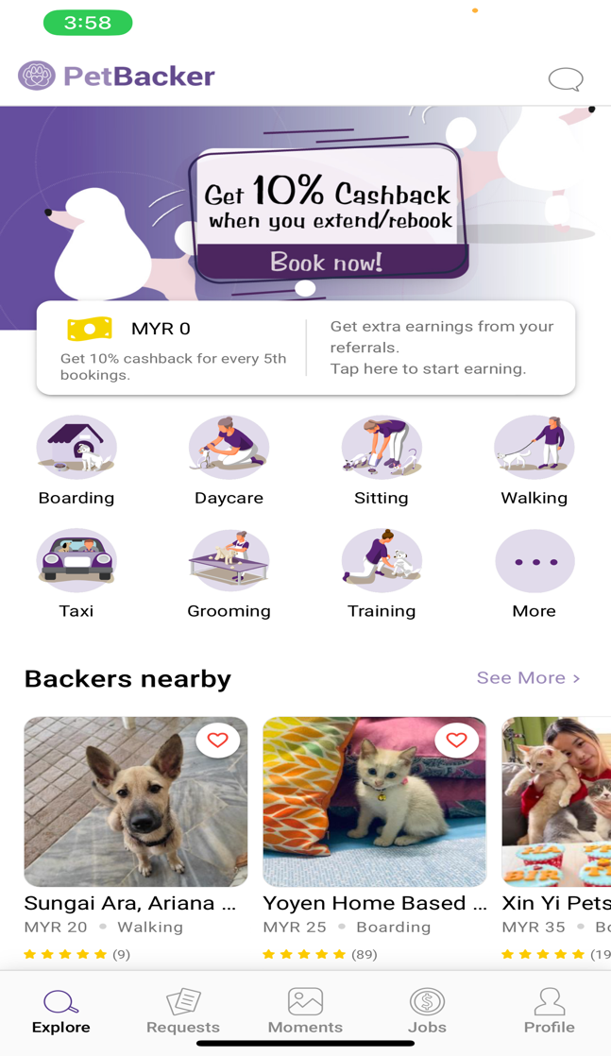

Figure 1: PetBacker App

An new and comprehensive mobile application called PetBacker was created to meet the various demands of pet owners. It functions as a virtual hub that links pet owners with a huge network of dependable and knowledgeable pet service providers. PetBacker provides a wide range of services to make sure that pets receive the care they require when their owners are abroad or unable to take care of them directly, including pet grooming, boarding, pet sitting, and dog walking.

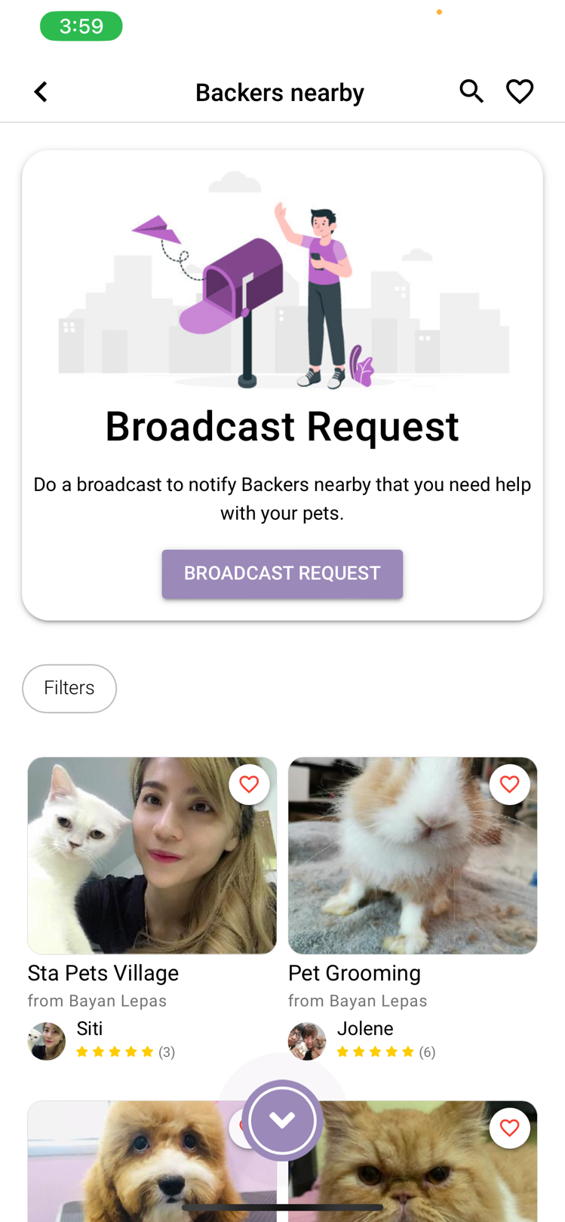

Figure 2: Service Providers

The vast network of pet service providers that PetBacker has is one of its unique advantages. The app connects a community of trained pet care professionals, including groomers, sitters, walkers, and boarders, who have all been screened and confirmed to meet the highest standards. This means that pet owners can rest easy knowing that their furry friends are in the care of competent, trustworthy people who are enthusiastic about their welfare.

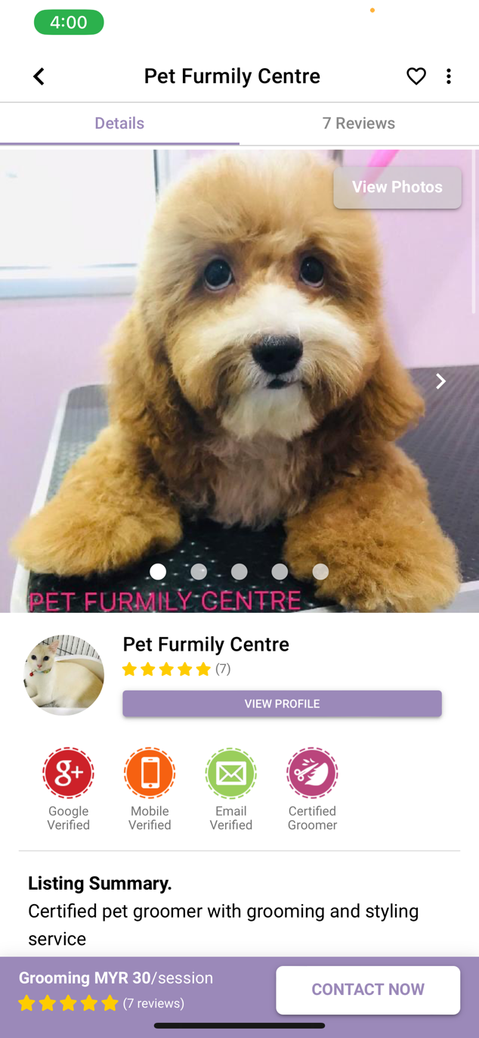 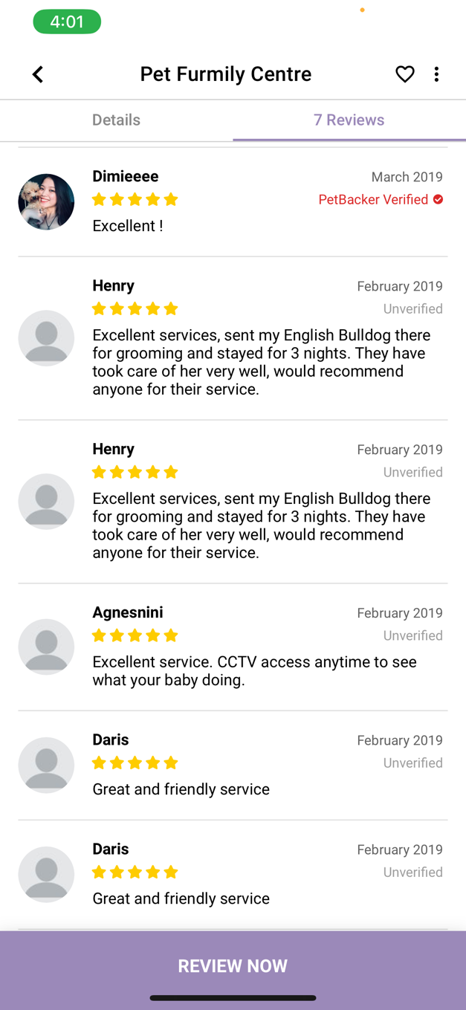

Figure 3: Groomer Details & Comments

The basic principles of PetBacker's design centre on convenience and use. Pet owners may easily search for and connect with service providers thanks to the app's user-friendly layout. Pet owners can gain a thorough idea of the experience and level of care provided by each provider through thorough biographies and client testimonials. This gives them the ability to choose the expert who is best suited for their dogs' particular needs and to make informed decisions.

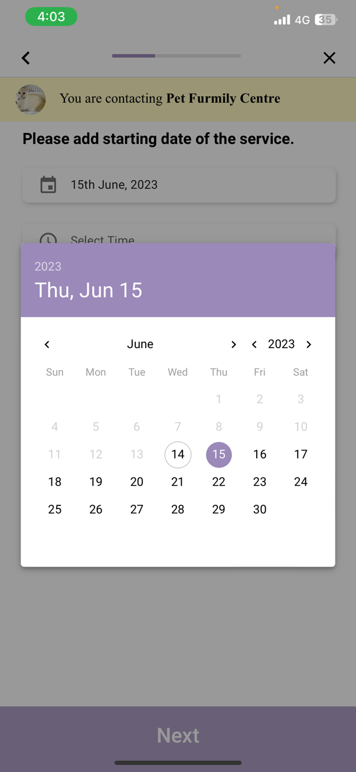 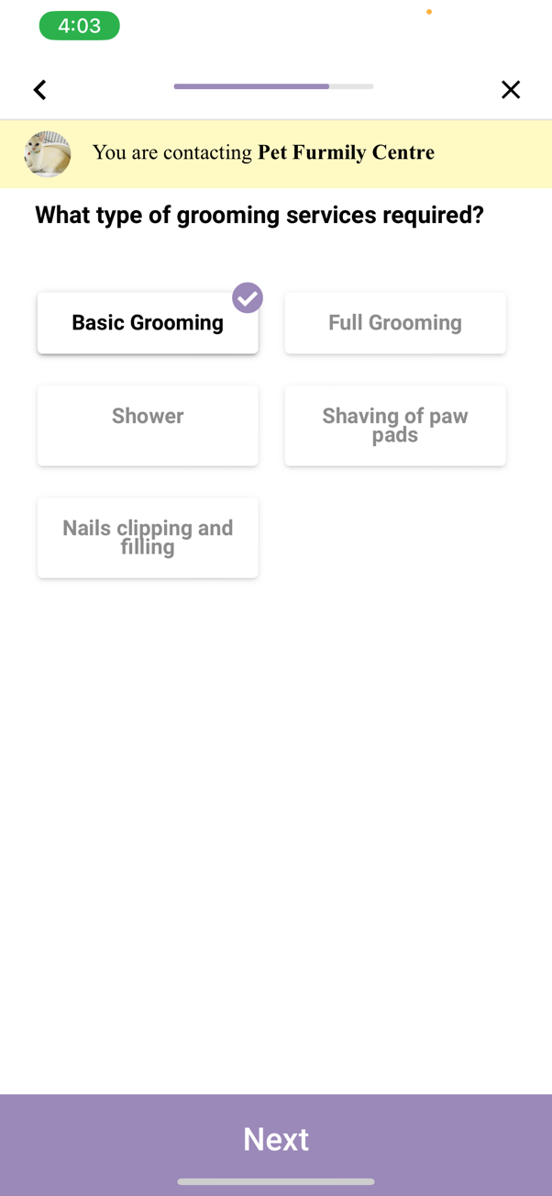

Figure 4: Scheduling System

Pet owners can quickly plan appointments and manage their pets' care needs with just a few taps on their mobile devices thanks to the integrated booking and scheduling system. PetBacker also has a handy reminder tool that notifies pet owners at the right times so they never forget key events or activities for their dogs. This function is especially helpful for time-pressed pet owners who may have a number of obligations and require a dependable system to monitor their pets' schedules.

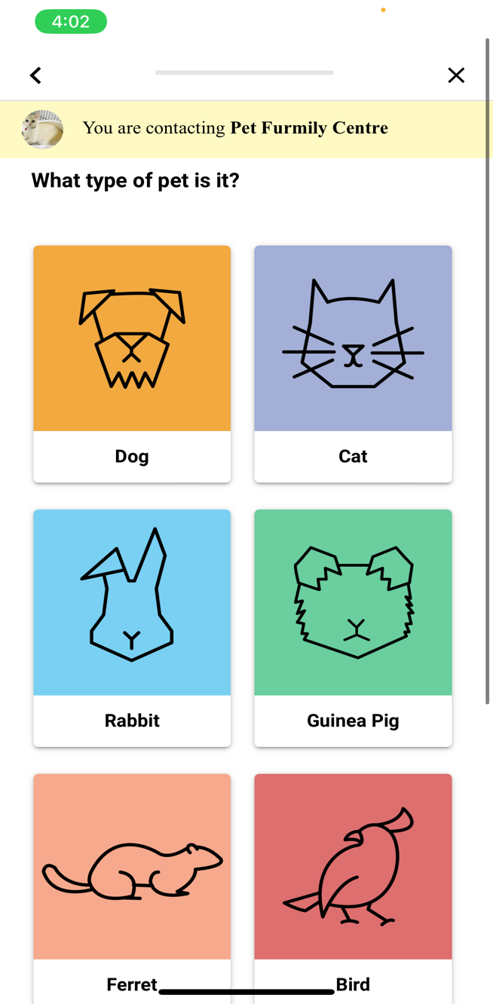 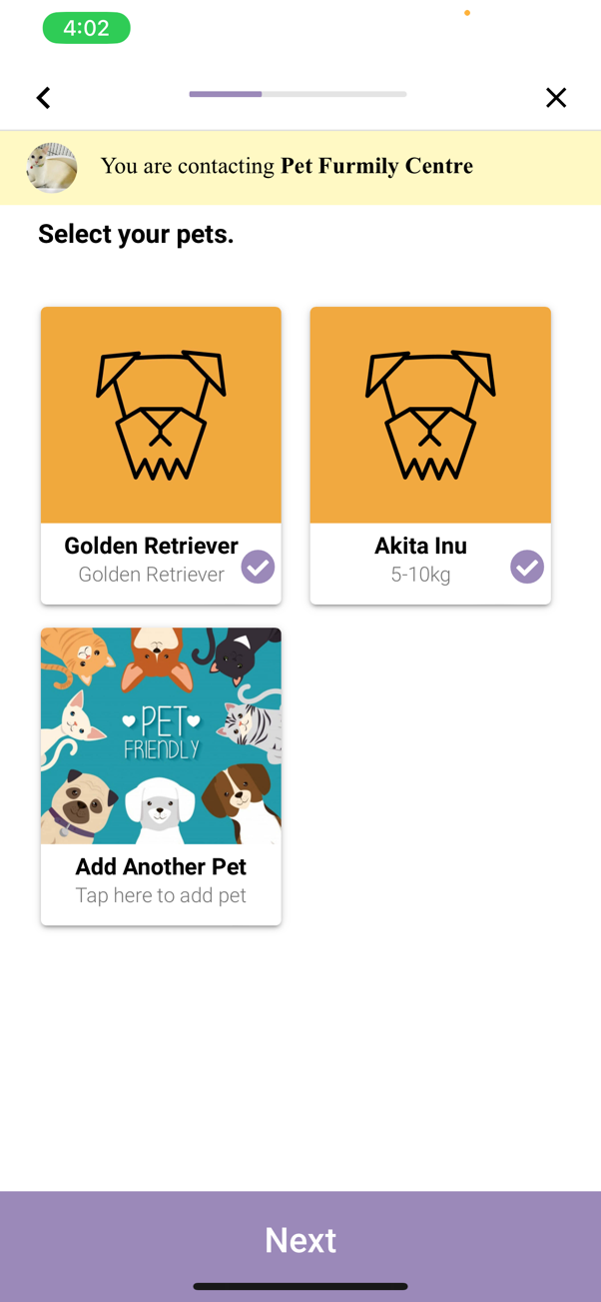

Figure 5: Multiple Pets Feature

PetBacker contains a feature where it allows pet owners to add multiple pets and keep track of them without hassle-free. They will be able to schedule multiple appointments for each pets at the same time, making it convenient to groom multiple pets and saves time.

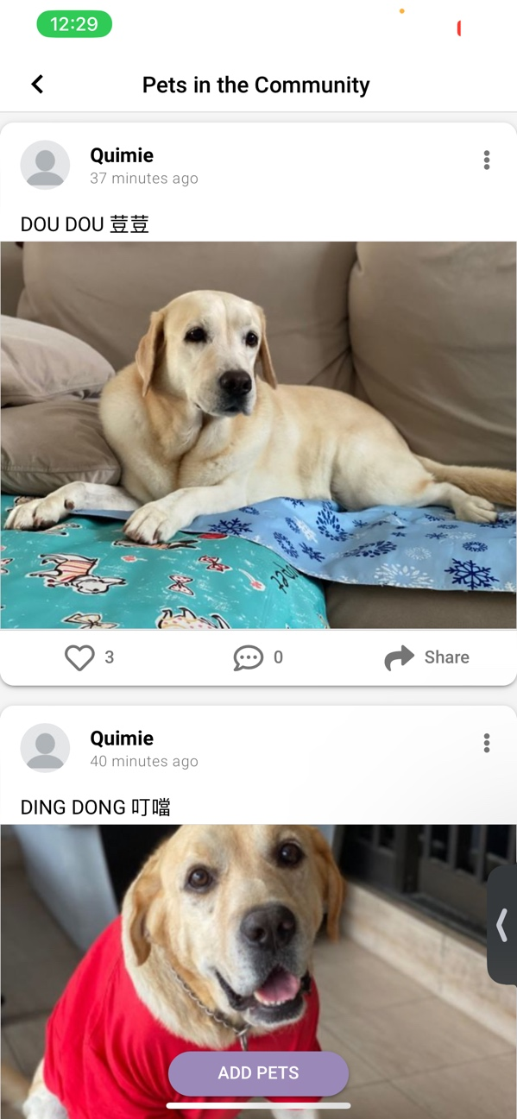 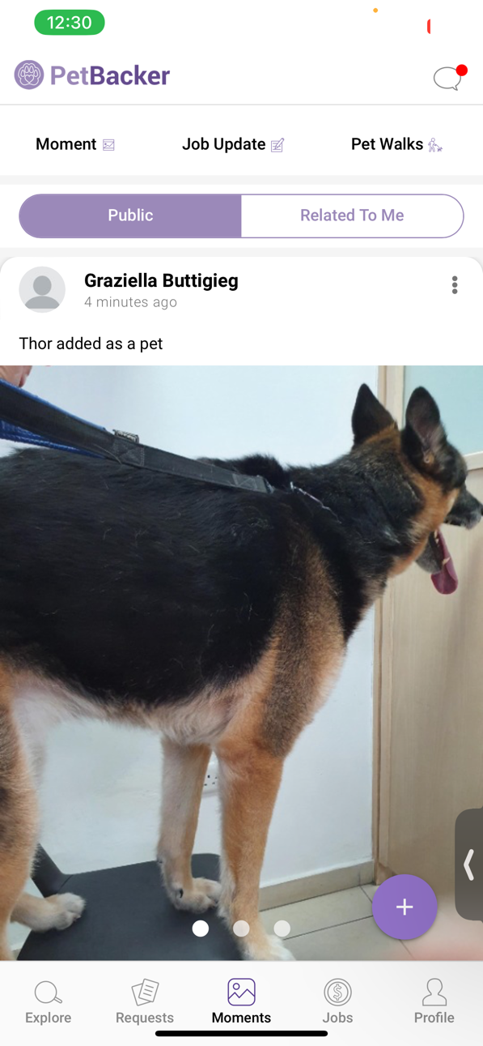

Figure 6: Pets Community

PetBacker does more than just link pet owners and service providers. It also provides a forum for pet owners to interact with one another and build communities of like-minded people who can exchange experiences, suggestions, and guidance. Pet owners can connect with people who share their love and passion for animals thanks to this community aspect, which provides an extra layer of support and involvement.

## **2.4 Features Derived to Groomify App**

The pet grooming booking app, Groomify will be implemented with the key features inspired by the PetBacker app. Groomify intends to offer pet owners and grooming specialists a seamless, effective, and personalised platform for accessing and managing grooming services by utilising these technologies. Let's look more closely at the main technological advantages of Groomify that will revolutionise the pet grooming sector.

By providing a powerful and intuitive mobile application, Groomify makes the most of mobile technology. The app's visually appealing and simple layout makes it easy for pet owners to browse through the several grooming options, examine price information, and simply book appointments. Pet owners can access Groomify's features anytime, anywhere with the help of the mobile app, offering optimum accessibility and convenience.

The app can offer a wide variety of pet services to meet the varied needs of pet owners. This involves, among other things, dog walking, pet sitting, and grooming. Every service should be accompanied by thorough explanations, pricing details, and availability so that pet owners can make educated selections based on the particular needs of their pets. The app turns into a one-stop shop for pet owners by providing a wide range of services, removing the need for them to use several platforms for various pet care requirements.

The pet service app's method for scheduling and booking appointments is an important feature. Pet owners should be able to conveniently arrange appointments for their pets thanks to the system's user-friendly and effective design. Pet owners should be able to tailor their pet care appointments to fit their schedules by having flexible options for choosing dates, times, and preferred service providers. The app should also provide flexibility and adaptation by making it simple for pet owners to monitor and adjust their bookings.

Pet owners can submit comments and discuss their experiences with service providers through the app's review and comment system. This function encourages openness and fosters trust among pet owners. Other pet owners may choose service providers wisely by allowing pet owners to express their opinions and score the services they received. By fostering a sense of accountability and community, the review and comment system guarantees the calibre and dependability of the pet care services made available through the app.

To ensure that pet owners are always aware of their forthcoming grooming appointments, the app includes digital reminders and notifications. Users get timely alerts and reminders, which makes it easier for them to efficiently manage the grooming schedule for their pets. By utilising this function, Groomify encourages routine grooming and helps to improve the general health and welfare of pets.

In conclusion, a PetBacker-inspired pet service app may include a simple user interface, a wide range of service options, a practical booking and scheduling system, reminder notifications, and a review and comment system. By enhancing the user experience as a whole, these improvements give pet owners a solid and effective foundation for managing the care needs of their animals. The app turns into a crucial resource for pet owners looking for reliable and high-quality pet care services because to its simple navigation, extensive service selection, easy booking and scheduling, timely reminders, and transparent feedback.

## **2.5 Comparison of Development Tools**

### **2.5.1 Database**

1. **Firebase**



Figure 7: Firebase Logo

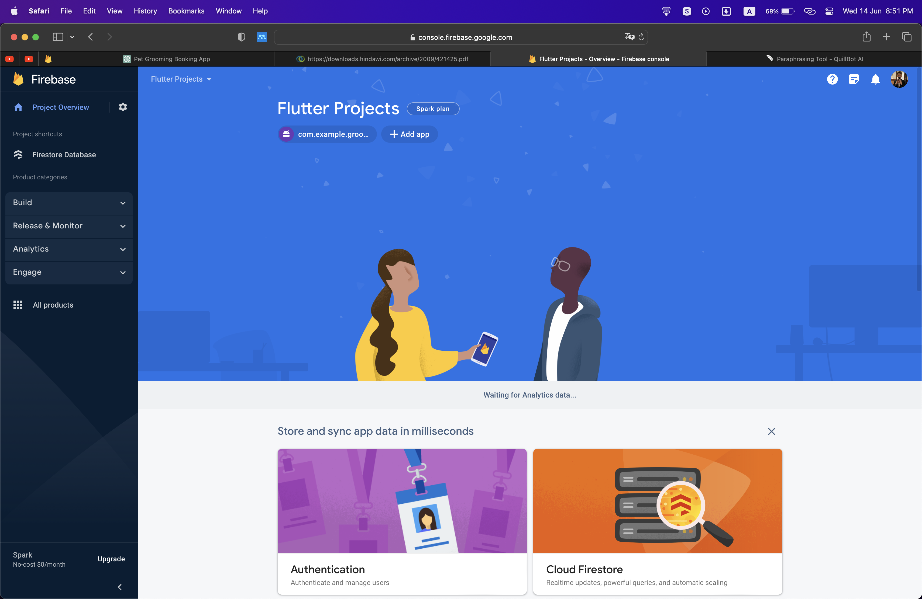

Figure 8: Firebase Interface

According to the journal (*The Definitive Guide to Firebase* 2017), Google offers Firebase, a comprehensive platform that provides diverse web and mobile application services. Among its features is the Firebase Realtime Database, a NoSQL cloud-hosted database intended for real-time data synchronization. It makes an outstanding choice for your pet grooming app development needs.

The Firebase Realtime Database offers a valuable advantage such as real-time synchronization. All connected clients receive instant updates whenever changes are made, keeping everyone in the loop at all times. This means if a pet groomer adjusts their schedule or a user books an appointment, the information is immediately available to everyone on any device. This seamless and synchronized experience ensures all users stay updated with current information.

Firebase Realtime Database's strong points include scalability and performance. It is designed to handle large amounts of data and concurrent connections, automatically scaling to meet the demands of an application. This ensures optimal app performance, even under high loads, providing a smooth and responsive user experience.

Firebase Realtime Database's offline support is a valuable feature for pet grooming app users. This feature ensures uninterrupted usage even when network connectivity is absent. The changes made by the users while offline saved locally and synchronized with the server automatically once there is network availability. This service guarantees that app users can continue to make updates in an offline environment without any interruption or data loss.

Additionally, Firebase Authentication, Cloud Storage, and Cloud Functions are all seamlessly integrated with Firebase Realtime Database. This enables you to improve your pet grooming app by utilising extra Firebase capabilities and services. For instance, you can utilise Cloud Functions to create server-side logic, Cloud Storage to store media files and photos, and Firebase Authentication to authenticate users.

1. **MySQL**

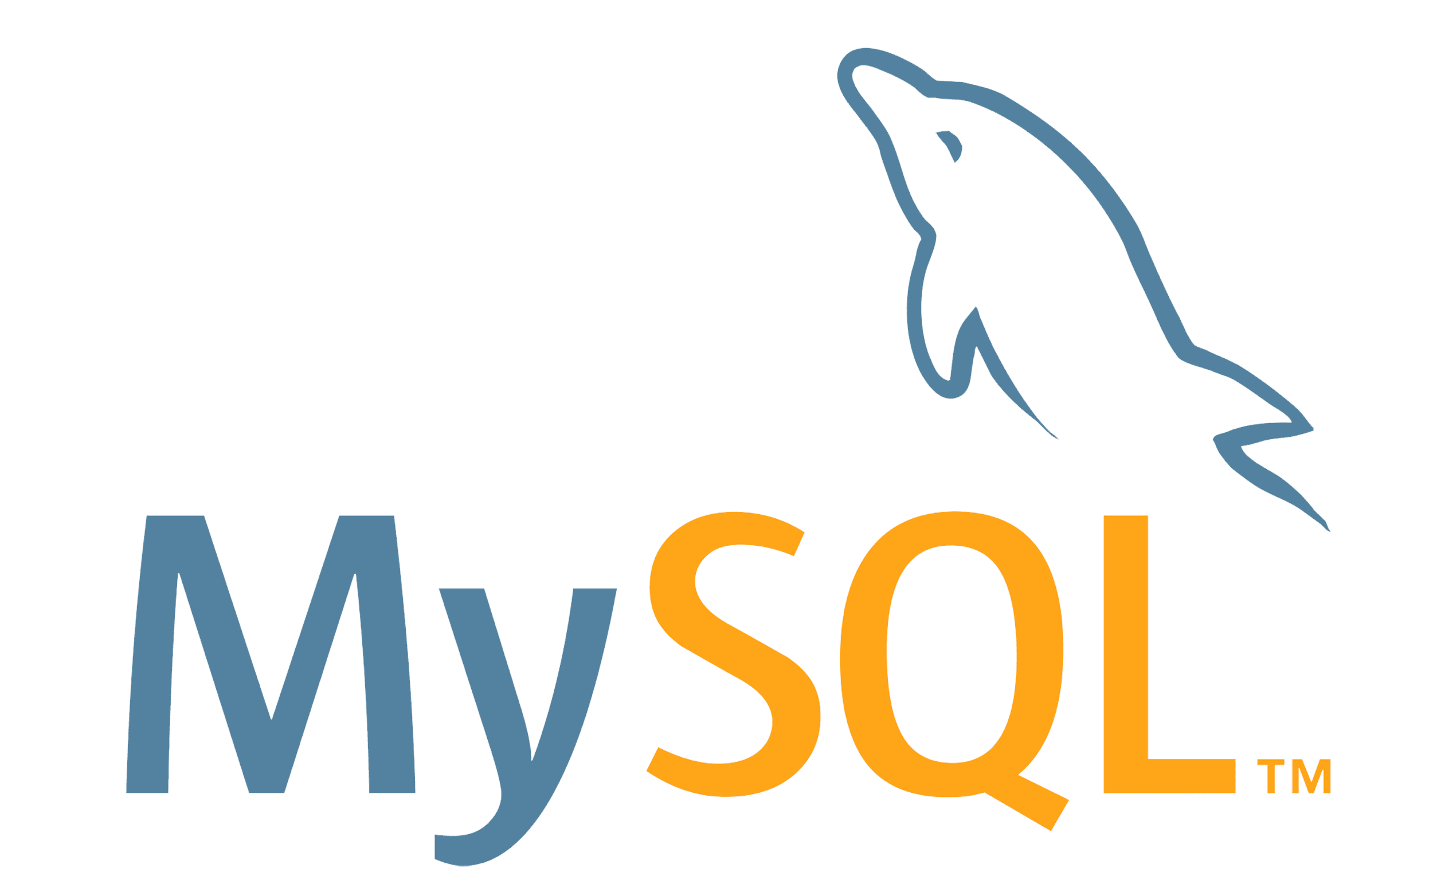

Figure 9: MySQL Logo

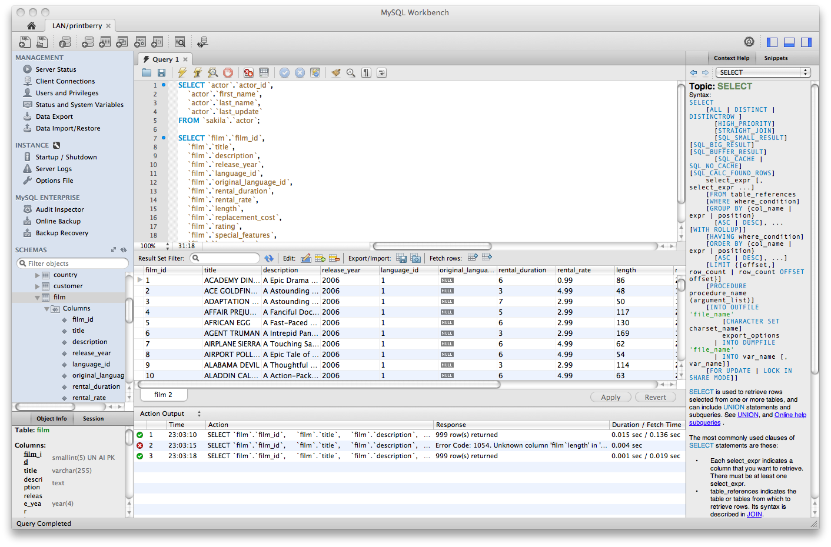

Figure 10: MySQL Interface

Based on the journal (*MySQL - Paul DuBois - Google Books* n.d.), An crucial tool in many contexts, including traditional uses in business, research, and educational settings as well as applications like those driving search engines on the Internet, a relational database management system (RDBMS) is used in many settings. Nevertheless, many organisations have discovered that, despite the value of a strong database system for maintaining and accessing information resources, it is out of their budgetary grasp. Database systems have always been expensive investments, with suppliers demanding steep prices for both software and service. Additionally, the cost was higher because database engines frequently needed a lot of hardware to operate at all reasonable performance levels. MySQL, which is one of a well-liked open-source relational database management system (RDBMS), as its database. It has several features and advantages that make it a good option for managing data in your application.

The adaptability and scalability of MySQL are two benefits. It has the capacity to manage enormous volumes of data and can be scaled to meet expanding data needs. In order to properly organise and arrange your data, MySQL supports a wide variety of data types and lets you build tables, relationships, and constraints.

The performance of MySQL is an additional advantage. It is designed to be quick and effective, enabling quick data retrieval and processing. Additionally, MySQL has indexing and query optimisation tools that can enhance the speed of your database searches and make sure that your pet grooming application can effectively handle a large number of requests.

Because MySQL is well-supported and has a sizable developer community, it is simpler to access materials, documentation, and assistance. You may seamlessly incorporate it with your pet grooming application because to its broad interoperability with a variety of programming languages, frameworks, and platforms.

Additionally, MySQL offers utilities and tools for managing and administrating databases. It provides command-line tools and graphical user interfaces (GUIs) that let you manage your database, execute backups and restores, and enhance database performance.

1. **MongoDB**



Figure 11: MongoDB Logo

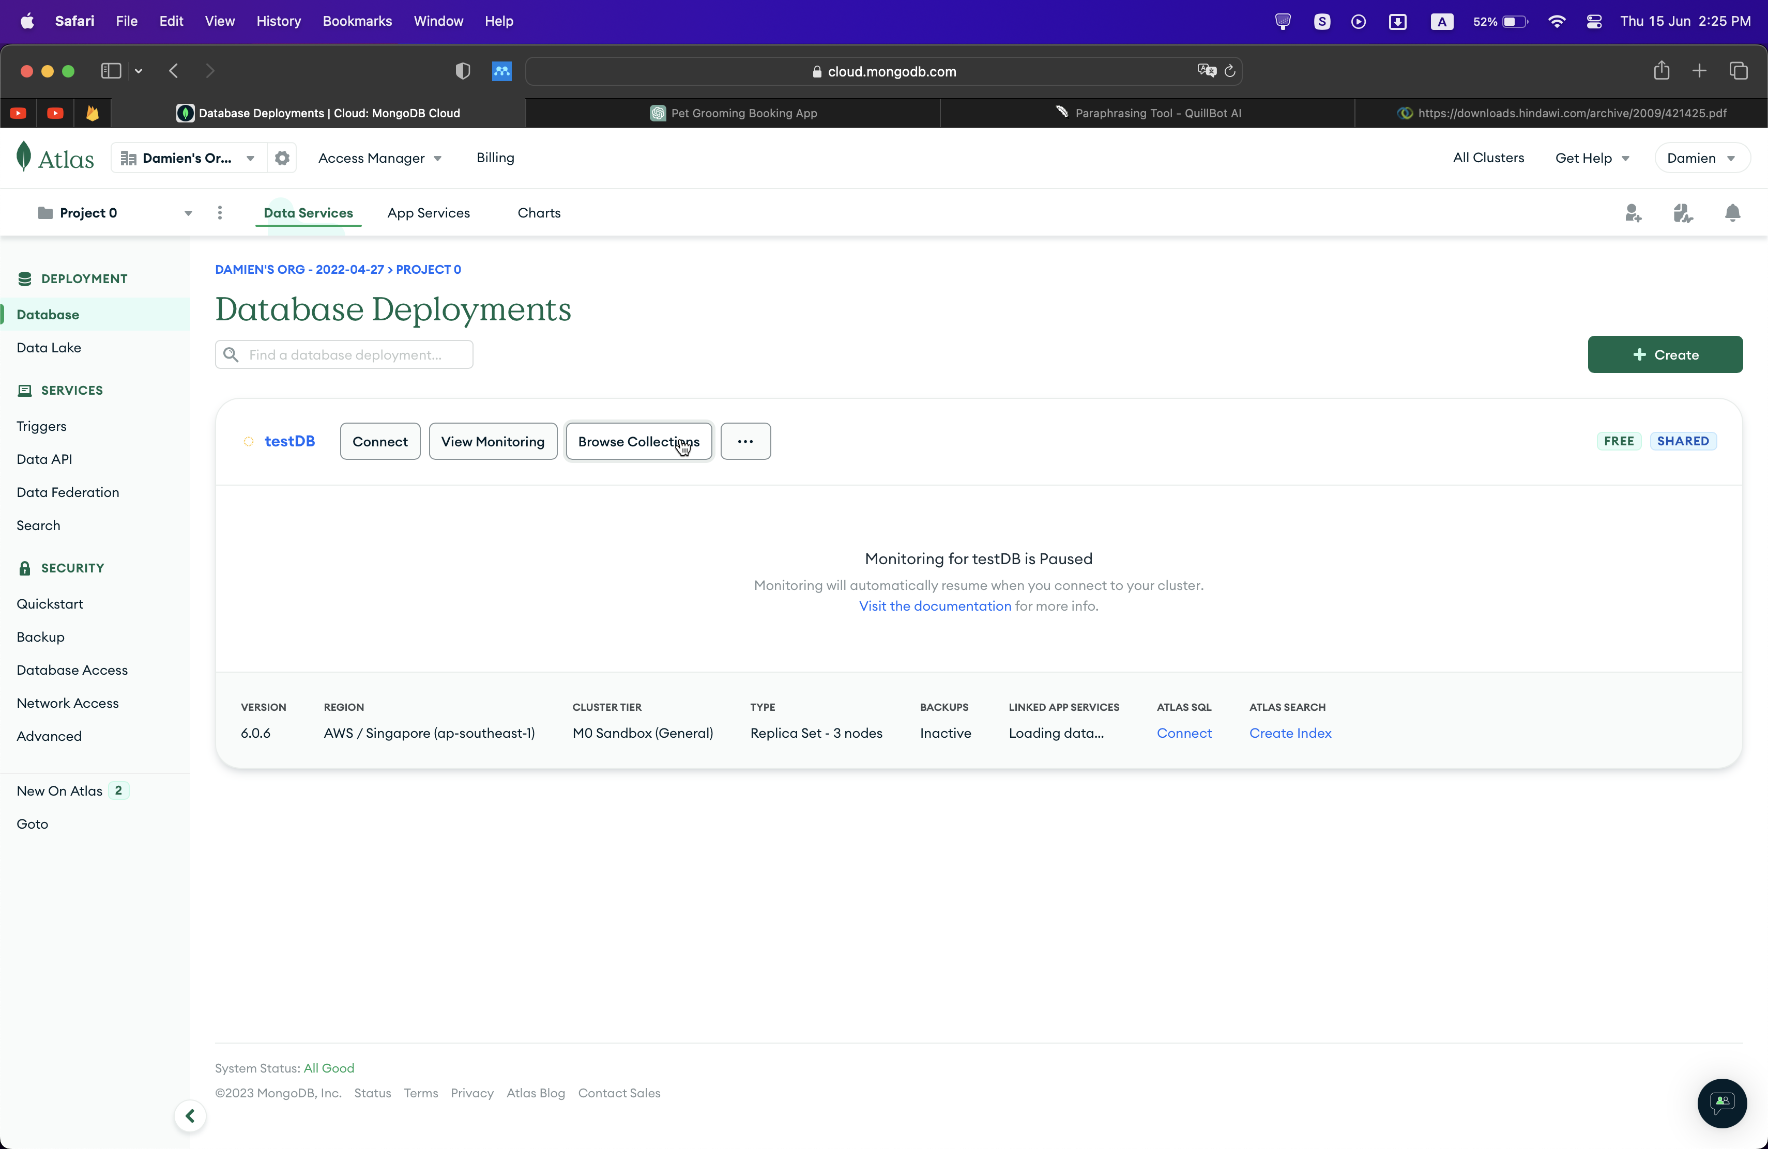

Figure 12: MongoDB Interface

Based on the journal (*MongoDB in Action: Covers MongoDB Version 3.0 - Kyle Banker, Douglas Garrett, Peter Bakkum, Shaun Verch - Google Books* n.d.), with a document-oriented data model, MongoDB is a well-known NoSQL database that offers various benefits for programmers and applications. MongoDB's versatility is one of its main advantages. You can store documents with various structures in the same collection because it supports dynamic schemas. Because of this flexibility, developers may simply modify and update their data models as the needs of their applications change over time.

The capacity to scale is yet another benefit of MongoDB. Because of its horizontal scaling capabilities, you can spread your data across a number of servers or clusters. With the help of built-in sharding and its horizontal scaling feature, MongoDB is able to efficiently handle enormous datasets and heavy traffic loads. MongoDB can handle rising read/write workloads and support expanding data volumes by splitting the data over several shards.

MongoDB has a robust query language that supports complicated operations for querying and indexing. It makes it simpler to retrieve the desired information from your data by enabling customizable filtering, sorting, and aggregating procedures. Additionally, MongoDB provides indexing, which greatly improves query efficiency by making it possible to quickly retrieve data based on particular fields.

MongoDB's high availability is an important feature. It has built-in replication capabilities that let you spread out numerous copies of your data across many servers or data centres. In the event of a server failure, automatic failover procedures take over to maintain data availability and reduce downtime. This replication ensures data redundancy and fault tolerance.

MongoDB is well-suited for situations where schemas may change often or are not predefined since it excels at handling unstructured or changing data. With MongoDB, you can run ad hoc queries without having to first build a schema, giving you more flexibility when handling dynamic data.

One of MongoDB's other noteworthy features is document validation, which enables you to enforce data consistency and integrity by defining validation rules for your documents. Additionally, MongoDB offers geographic features that make it simple to store and query location-based data.

With a wide ecosystem of tools, libraries, and resources accessible, the MongoDB community is alive and thriving. It provides comprehensive training, community assistance, and documentation, which makes it simpler for developers to understand and use the database successfully.

|  |  |  |  |
| --- | --- | --- | --- |
| **Features** | **Firebase** | **MongoDB** | **MySQL** |
| NoSQL Database | Yes | Yes | No |
| Real-time Updates | Yes | No | No |
| Scalability | Yes | Yes | Yes |
| JSON Data Model | Yes | Yes | No |
| ACID Transactions | No | No | Yes |
| Schema Flexibility | No | Yes | No |
| Data Replication | Yes | Yes | No |
| Data Validation | Yes | No | Yes |
| SQL Support | No | No | Yes |
| Indexing | Limited | Yes | Yes |

Table 1: Comparison of Firebase, MongoDB & MySQL

Because of a number of important factors, Firebase is an appealing option for application development. First off, because of its real-time database's ability to synchronise updates across different clients, it is perfect for applications that need real-time data updates. Second, Firebase provides automatic load balancing and scalability, guaranteeing that your application can manage increasing traffic and data quantities. Thirdly, access to extra functionalities is made possible by the smooth integration of other Google Cloud services. In addition, Firebase offers integrated access control and encryption as well as authentication and security measures. Its NoSQL database, Firestore, additionally provides adaptability, scalability, and potent querying features. Finally, Firebase Hosting makes it easier to deploy online applications. Firebase provides a compelling platform for creating dynamic and secure applications because to its extensive capabilities and solid infrastructure.

### **2.5.2 Programming Language**

1. **Flutter & Dart**

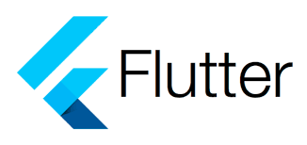

Figure 13: Flutter Logo

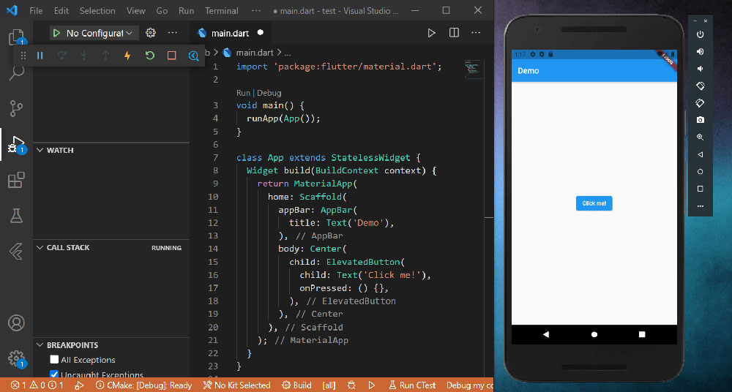

Figure 14: Flutter Interface

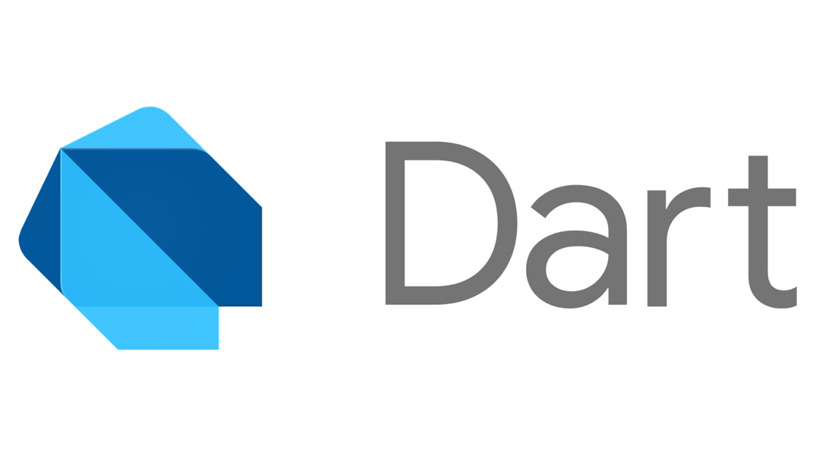

Figure 15: Dart Logo

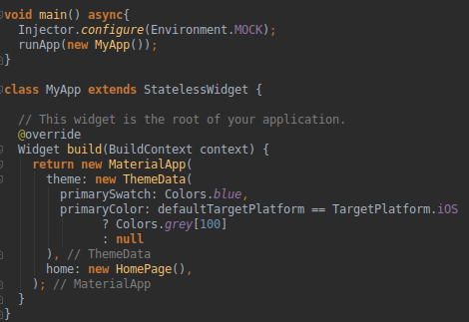

Figure 16: Dart Language

From the journal (*Sci-Hub | Beginning App Development with Flutter | 10.1007/978-1-4842-5181-2* n.d.), Google created the mobile SDK Flutter, which is open-sourced and focused on enabling everyone to create stunning mobile applications. Flutter makes it simpler than ever to design mobile apps in a familiar, streamlined manner, regardless of whether you have experience with web programming or native mobile development. Flutter is unique in that it makes it possible to "write once, and deploy everywhere." Flutter apps will roll out to Android, iOS, and ChromeOS as of this writing. Flutter apps will soon be available as desktop and web applications for all of the major operating systems. Flutter is a fully comprehensive SDK for building applications, to put it briefly. It's a platform that offers a rendering engine, UI components, testing frameworks, tooling, router, and many other capabilities you'll need to build applications. You can now concentrate on the intriguing issues in your software as a result. The domain functioning can be your exclusive area of attention while everything else is taken care of. The benefit that Flutter offers is astounding.

Based on the journal (*Flutter for Beginners: An Introductory Guide to Building Cross-Platform ... - Alessandro Biessek - Google Books* n.d.), Flutter framework's foundation is made on the Dart programming language. For the optimal developer experience and to enable the development of amazing mobile applications, a modern framework like Flutter needs a high-level modern language. Google created the Dart programming language, which may be used to create desktop, server-side, web, and mobile apps. Flutter apps are created using the programming language Dart, which gives developers the finest experience possible while building sophisticated mobile applications.

Dart's object-oriented structure, which enables programmers to organise code using classes, objects, and inheritance, is one of its main features. This improves code reuse and makes it simpler to cooperate on projects. It also makes it easier to structure and manage code.

Static typing is another feature of Dart that enables compile-time type verification and aids in the early detection of mistakes. This feature can improve code dependability and lower the frequency of runtime errors, resulting in programmes that are more reliable and stable.

Another crucial component of Dart is asynchronous programming. Using constructs like async/await and Futures, Dart's native support for asynchronous operations enables programmers to create non-blocking code that can effectively handle tasks like network requests or file operations. This makes it possible to develop programmes that are quick and efficient and can manage several activities at once.

Dart gains much greater capability when used with the Flutter framework. Flutter makes use of Dart's characteristics to create stunning and engaging user interfaces for a variety of platforms, such as iOS, Android, the web, and desktop. Dart and Flutter enable code sharing between platforms, cutting down on the time and effort required for development.

Dart gains from a thriving ecosystem and a growing developer community. Through forums, documentation, and libraries, the Dart community actively contributes to the language and provides support. The ecosystem provides a wide selection of packages and tools that can enhance Dart's functionality and make routine development activities easier.

The Hot Reload functionality of Dart and Flutter is one of its best qualities. Developers can make changes to their code and immediately see the improvements reflected in the active application thanks to Hot Reload. As a result, the development process is greatly sped up, and speedy experimentation and iteration are made possible.

1. **Java**

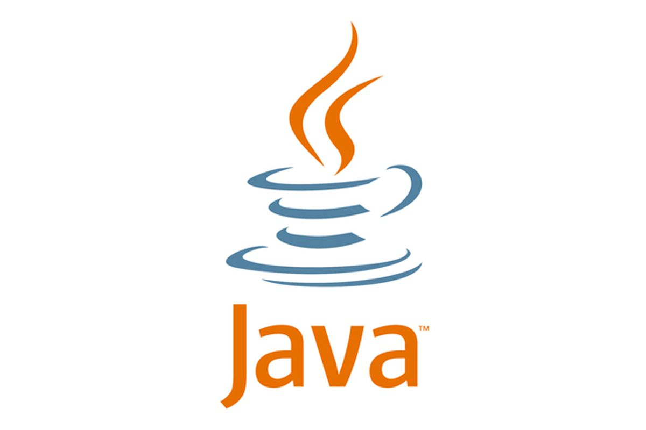

Figure 17: Java Logo

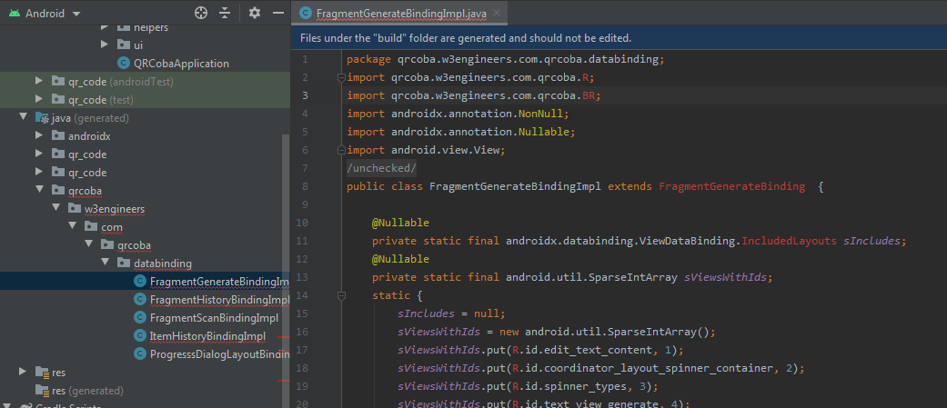

Figure 18: Java Language

Based on the journal (*Programming Android - Zigurd Mednieks - Google Books* n.d.), as an object-oriented language, Java places more of an emphasis on objects—combinations of data—and procedures for manipulating those objects. The fields (data) and methods (procedures) that make up an object are specified by a class. A Class is a specific type of object that serves as the template from which other objects are built. Classes serve as the cornerstone of Java's type system, which enables programmers to specify arbitrary levels of complexity in terms of an object's state and behaviour. Toes may inherit from other types in Java, as they can in the majority of object-oriented languages. A class is said to subtype or be a subclass of its parent if it inherits from another class. In turn, the Parent class may be referred to as the Subtype or Superclass. The base type for those subclasses is a class that has a variety of various subclasses. Within the class, both fields and methods have a global scope and may be accessed from outside the object by using a reference to a class instance.

Java provides a number of essential characteristics that make it suited for creating mobile applications. First and foremost, it is platform-independent, allowing Java code to execute on a variety of operating systems, including desktop environments, iOS, Android, and RoboVM. This saves time and effort by allowing developers to write code once and deploy it across various platforms.

Java's object-oriented programming (OOP) paradigm is one of its advantages. Java enables programmers to write reusable, modular code through the use of classes, objects, and inheritance. Complex mobile app projects can be more easily managed thanks to OOP concepts, which encourage code organisation, maintainability, and extensibility.

Java offers a wide variety of libraries and frameworks that make it easier to create mobile applications. For instance, since the Android platform is based on Java, developers may access a wide range of APIs, libraries, and tools through the comprehensive Android SDK (Software Development Kit) to create feature-rich and engaging Android apps.

Java also enables multithreading, enabling programmers to manage several tasks at once. This is especially helpful for mobile apps that need real-time updates or background tasks, such messaging apps or apps that download data from distant sites.

1. **Kotlin**

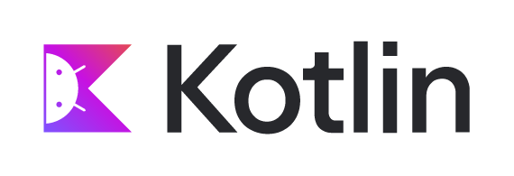

Figure 19: Kotlin Logo

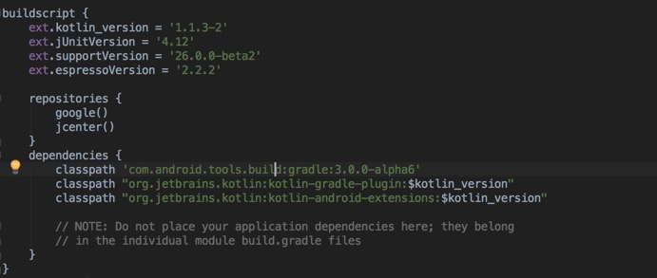

Figure 20: Kotlin Language

Based on the journal (*Android Development with Kotlin - Marcin Moskala, Igor Wojda - Google Books* n.d.), Kotlin is a contemporary, strictly typed, Android-compatible language called Kotlin resolves several Java issues like null pointer exceptions and too verbose code. Languages like Swift, Scala, Groovy, C#, and many others served as inspiration for Kotlin. Kotlin was created by JetBrains experts based on a study of both developers' experiences, the best usage recommendations (the most crucial being clean code and effective Java), and usage statistics for this language. Other programming languages have been thoroughly investigated. Kotlin makes a concerted effort to avoid the flaws of other languages and capitalise on their best traits. Working with Kotlin makes it clear that this is a sophisticated, well-designed language.

By enhancing code quality and security and enhancing developer productivity, Kotlin elevates application development to a whole new level. Google announced official Kotlin support for the Android operating system in 2017, however the Kotlin language has existed for a while. It has a thriving community, and the use of Kotlin on the Android platform is already accelerating. We can characterise Kotlin as a secure, expressive, succinct, adaptable, and tool-friendly language with excellent Java and JavaScript interoperability.

Based on the journal (*Kotlin in Action - Dmitry Jemerov, Svetlana Isakova - Google Books* n.d.), the null safety feature of Kotlin is one important benefit. Null pointer exceptions, a typical cause of defects in Java, can be avoided with Kotlin's built-in null safety support. Kotlin ensures safer handling of null values and lowers the danger of runtime crashes brought on by null references by differentiating between nullable and non-nullable types.

The principles of functional programming are also used in Kotlin. It has substantial support for immutability, lambda expressions, and higher-order functions. Developers can use functional programming principles, write more expressive and succinct code, and write code that is easier to comprehend and maintain as a result.

The coroutines in Kotlin are one of its distinguishing qualities. Programming asynchronously and concurrently is made easier by the use of lightweight constructs called coroutines. They make asynchronous operations simpler to handle and reason about by enabling developers to create asynchronous code in a sequential and synchronous form. Coroutines are particularly helpful for managing asynchronous tasks more effectively and logically, including network requests, database operations, and other tasks.

Excellent tooling support is available for Kotlin, including a potent IDE plugin for IntelliJ IDEA, Android Studio, and other well-known IDEs. Code completion, refactoring tools, and error highlighting are just a few of the IDE support features that improve developer experience and productivity. Additionally, Kotlin is a language that is officially supported for creating Android apps, allowing for seamless integration into the Android developer community.

Kotlin encourages compatibility with current Java code. It is simple to connect with Java, enabling developers to reuse Java libraries and frameworks and progressively switch current applications over to Kotlin. Because of its interoperability, Kotlin is a sensible option for programmers who wish to use their existing Java codebase while taking use of a cutting-edge programming language.

Last but not least, Kotlin benefits from a vibrant community. The community actively contributes libraries, frameworks, and tools to improve the Kotlin ecosystem as a result of its rising popularity. It is simpler for developers to acquire and use Kotlin because there are learning tools, documentation, and community assistance available.

|  |  |  |  |
| --- | --- | --- | --- |
| **Feature** | **Dart** | **Java** | **Kotlin** |
| Easy to learn | Yes | Yes | Yes |
| Interoperability | Yes | Yes | Yes |
| Concise syntax | Yes | No | Yes |
| Null safety | Yes | No | Yes |
| Functional programming | Yes | No | Yes |
| Coroutines | No | No | Yes |
| Excellent tooling support | Yes | Yes | Yes |
| Android development support | Yes | Yes | Yes |
| Performance | Yes | Yes | Yes |
| Community support | Yes | Yes | Yes |
| Large codebase | No | Yes | Yes |
| Popularity | No | Yes | Yes |

Table 2: Comparison of Dart, Java & Kotlin

Dart is a strong and flexible programming language that is especially well suited for creating mobile apps with the Flutter framework. It is a desirable option due to its cross-platform capabilities, robust performance, static typing, concise syntax, solid tools support, and active community. Developers may produce apps that work flawlessly on the iOS and Android platforms by using the Dart programming language. The straightforwardness, abundance of tooling, and welcoming community of the language facilitate a more efficient development cycle and quicker iteration. Additionally, the writer is experience in Flutter and Dart thus making it a better choice. Overall, the experience in Flutter and Dart allows the writer to create top-notch mobile apps with a compelling collection of capabilities and advantages.

### **2.5.3 Operating System**

According to the journal (Wukkadada et al. 2015), An operating system utilised in mobile devices is called a mobile operating system. This operating system is essentially a lightweight operating system that uses less memory and storage. This operating system, sometimes referred to as mobile OS or mobile OS, can be used in PDAs, tablets, smartphones, and other devices. All the features of a personal computer are combined into mobile operating systems. A touchscreen, cellular Bluetooth, WI-FI, GPS mobile navigation, camera, video camera, speech recognition, music player, voice recorder, near field communication, and infrared blaster are all included in mobile operating systems. Multiuser, multiprocessing, and multitasking are aspects of mobile operating systems. Mobile communication is a feature of mobile operating systems. Currently, the most popular mobile OS are android and ios.

1. **Android**

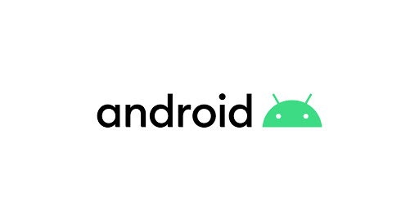

Figure 21: Android Logo

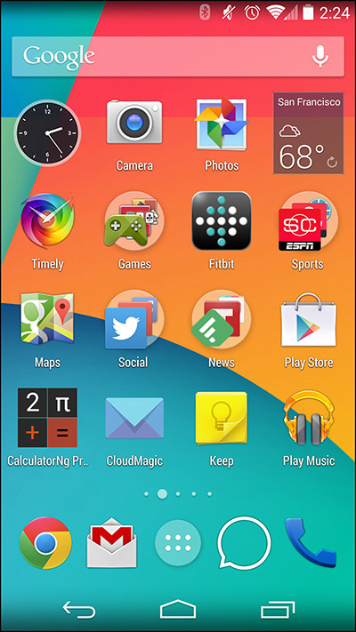

Figure 22: Android Interface

Android is a collection of software that consists of a mobile operating system, middleware, and important applications. On September 23, 2008, Android made its debut. Both an operating system and a software platform, Android is. Google created the Android mobile operating system, which is based on the lightweight Linux operating system. The Android operating system enables programmers to create applications in a language similar to Java that use Java libraries created by Google. The Android architecture is made up of the Linux Kernel, Android Runtime, and Core Libraries. Android stores data using SQLite. All types of network connectivity, including GSM, EDGE, 3G, LTE, and WiFi, are supported by Android. Due to its Linux OS foundation, it comes preinstalled with all necessary drivers and supports OTG (one the go) for any external devices. Voice recognition and multiple users are also supported. Alpha was the first Android version, while lollipop is the most recent.

Being an open-source mobile operating system, Android has a number of benefits that make it a popular option for both users and developers. First off, Android has a far bigger market share than other operating systems, giving developers access to a huge user base and more opportunities to connect with their target market. Additionally, Android runs on a variety of devices made by different companies, enabling developers to support a range of hardware requirements and user preferences.

Support for numerous programming languages, particularly Java and Kotlin, is one of Android's advantages. With this flexibility, developers are able to select the language that best suits their needs or preferences for their project, resulting in quick and easy development cycles. Additionally, Android has a wide range of customisation choices, allowing designers to create user interfaces that are aesthetically pleasing and extremely interactive. The option for users to customise their Android smartphones results in a more interesting and customised user experience.

The seamless integration of Android with Google services is another benefit. Developers can improve the functionality of their applications and give customers simple access to well-liked and widely-used services by utilising services like Google Maps, Gmail, and Drive. The whole user experience is improved as a result of this integration, which also simplifies the development process.

Developers also have access to the most recent tools, technologies, and features thanks to Android's dedication to constant innovation and frequent updates. This enables them to maintain their leadership position in mobile app development and take use of new tools to produce cutting-edge applications.

1. **IOS**

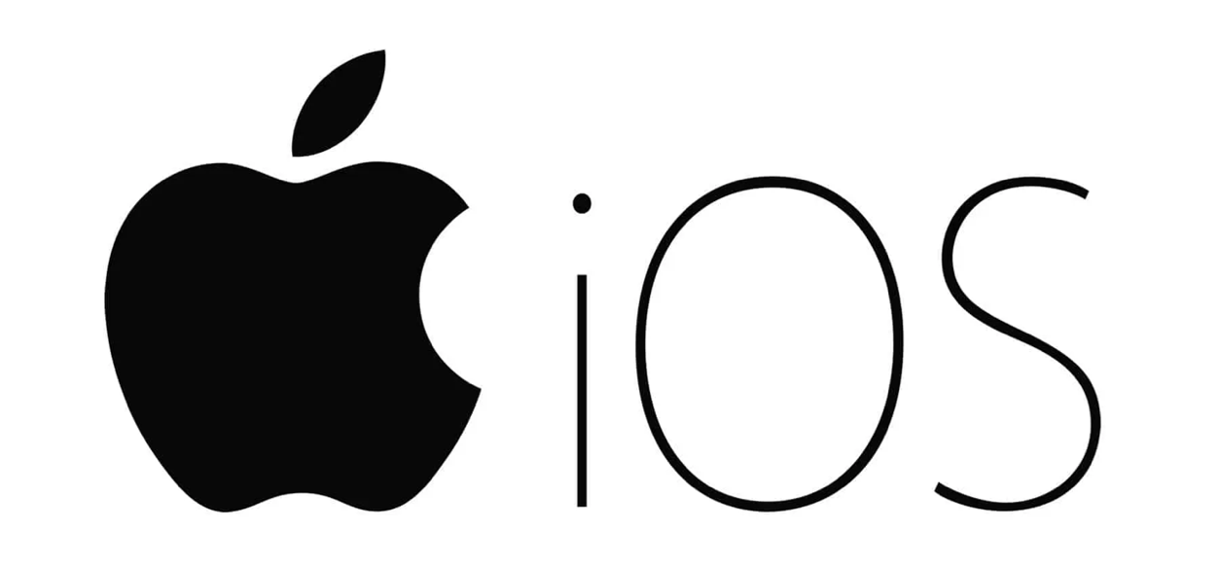

Figure 23: IOS Logo

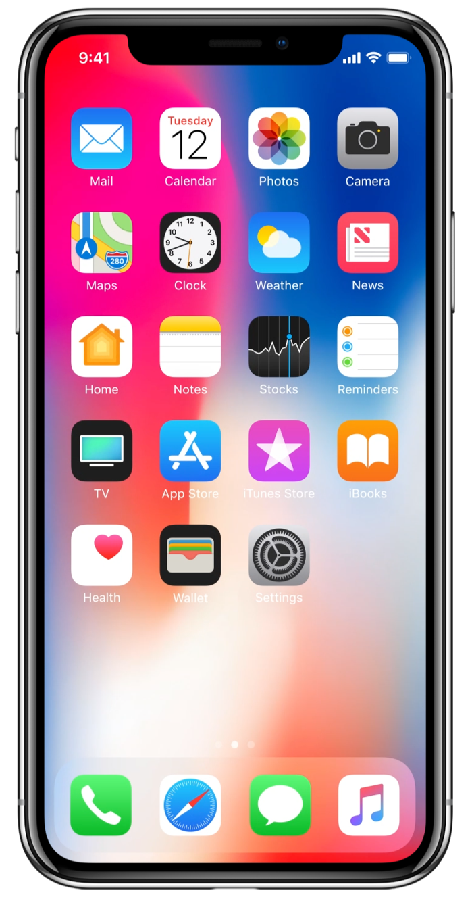

Figure 24: IOS Interface

IOS is a mobile operating system that Apple Inc. created for the iPhone. Both the iPad and the iPod Touch were used to deploy it. IOS originally became available on June 29, 2007. IOS was created particularly for Apple hardware and is descended from Mac OS X, with which it shares the Darwin foundation. As a result, IOS is a Unix-based operating system by nature. The Media layer, the Cocoa Touch layer, the Core OS layer, and the Core Services layer are IOS' four abstraction layers. IOS also supports every network connectivity type, including GSM, EDGE, 3G, LTE, and WiFi. A distinctive platform for sensor applications is offered by IOS hardware. Using Apple IOS to create sensor applications has a number of benefits over conventional methods. It is challenging for designers to provide dependable communication and useful user interfaces while using an IOS-based accessory. By not using the system's communication and processing components, the problem can be avoided. Here, the term "accessory" essentially refers to a connection to the IOS hardware. Both the hardware and the sensor components would be included in this accessory. We will also examine the automatic collection of failure data from the IOS platform in this research. Due to its closed-source nature, gathering failure data is not simple. IOS 1.0 was the initial version, while the most recent version, IOS 8.0, has more functions.

The operating system that Apple created for its mobile devices, iOS, has many benefits that make it a popular option for users and developers. First of all, iOS is renowned for integrating seamlessly with Apple hardware, creating a highly optimised and effective user experience. Fast performance, fluid animations, and long battery life are all features that iOS devices are able to offer because to the close integration of hardware and software.

iOS places a lot of emphasis on privacy and security, which is one of its main benefits. User data is safeguarded and applications are reliable because to Apple's tight app review policies, app sandboxing, and other strong security features. Because of its focus on security and privacy, iOS is a top option for organisations and individuals who value data security.

Additionally, iOS delivers a standardised user interface that is consistent across all devices, giving users a comfortable and simple experience. Apple's high design standards and quality control lead to applications that are aesthetically pleasing and easy to use. Because developers can only build and test programmes for a finite range of device models and screen sizes, this uniformity also streamlines the development process.

|  |  |  |
| --- | --- | --- |
| **Advantages** | **Android** | **IOS** |
| Open-source | Yes | No |
| Customizability | Yes | No |
| Hardware variety | Yes | No |
| App distribution | Multiple app stores | App Store only |
| Fragmentation | Yes | No |
| Development tools | Java, Kotlin, C++ | Swift, Objective-C |
| Market share | Higher globally | Lower globally |
| Price range | Wide range of devices at different price points | Limited range of premium devices |
| Ecosystem | Integrated with Google services and third-party platforms | Integrated with Apple services and limited third-party platforms |
| User base | Diverse user base across different demographics | More affluent and tech-savvy user base |

Table 3: Comparison of Android & IOS

In this project's environment, Android has a number of advantages over iOS. First off, because it is open-source, Android gives developers more freedom and customization choices to adapt the programme to certain needs. Furthermore, Android offers a variety of hardware alternatives, making it compatible with a variety of devices and price points. Android gives more freedom in terms of app distribution thanks to its availability in several app stores. The diversified user base of Android and its connection with a number of Google services and platforms make it suited for reaching a wider audience, despite the difficulties that fragmentation might cause. Android would ultimately offer greater customization, interoperability, and market reach for this project.

### **2.5.4 Frameworks**

1. **Figma**



Figure 25: Figma Logo

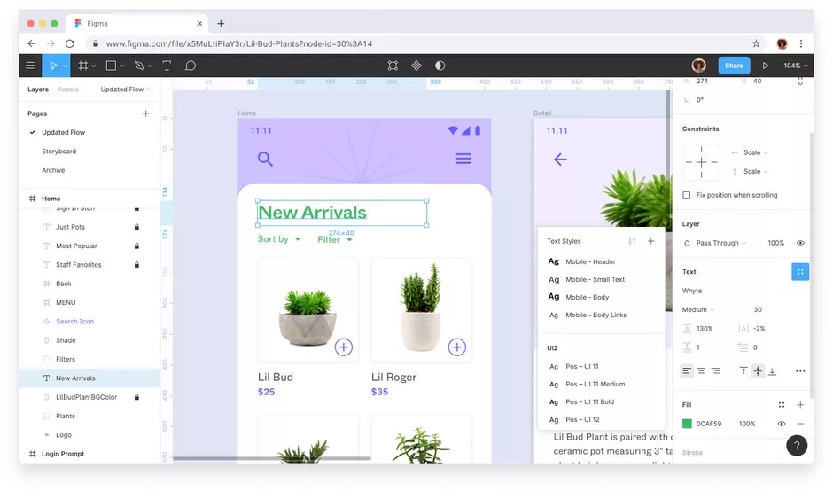

Figure 26: Figma Interface

Based on the journal (*Designing and Prototyping Interfaces with Figma: Learn Essential UX/UI ... - Fabio Staiano - Google Books* n.d.), Figma is a powerful real-time collaborative tool that can easily replace several design applications. In other words, it is a well-liked web-based design and prototyping tool that designers and teams use to make interactive prototypes, wireframes, and user interfaces. It has a number of benefits that make it a popular option for many design projects.

First of all, Figma is a teamwork solution that enables seamless teamwork and real-time collaboration. Because multiple users can work on a project at once, it is perfect for design teams collaborating on challenging tasks. The option to provide comments and input while viewing changes in real-time improves collaboration and speeds up the design process.

The fact that Figma is cloud-based is another benefit. There is no requirement for software installation or ongoing updates because Figma is web-based. Design files are conveniently available from any location with an internet connection thanks to cloud storage. Version control difficulties are eliminated, and designers may work on their designs using various devices thanks to this.

A complete range of design and prototyping features are also available in Figma. It offers a variety of capabilities, such as vector editing, text style, and shape manipulation, for generating and modifying design elements. Designers may more easily communicate and evaluate design concepts thanks to interactive prototyping tools that allow them to construct clickable prototypes and replicate user interactions.

Figma also has a sizable and vibrant design community. Users have access to a sizable library of design tools, templates, and UI kits that have been made available by the community, which helps to streamline the design process and provide opportunities for inspiration and knowledge sharing.

Finally, it's important to note Figma's platform-independent strategy. It operates without a hitch on Windows and Mac operating systems, guaranteeing interoperability with various environments and letting designers select their favourite operating system without any restrictions.

1. **Adobe XD**

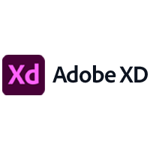

Figure 27: XD Logo

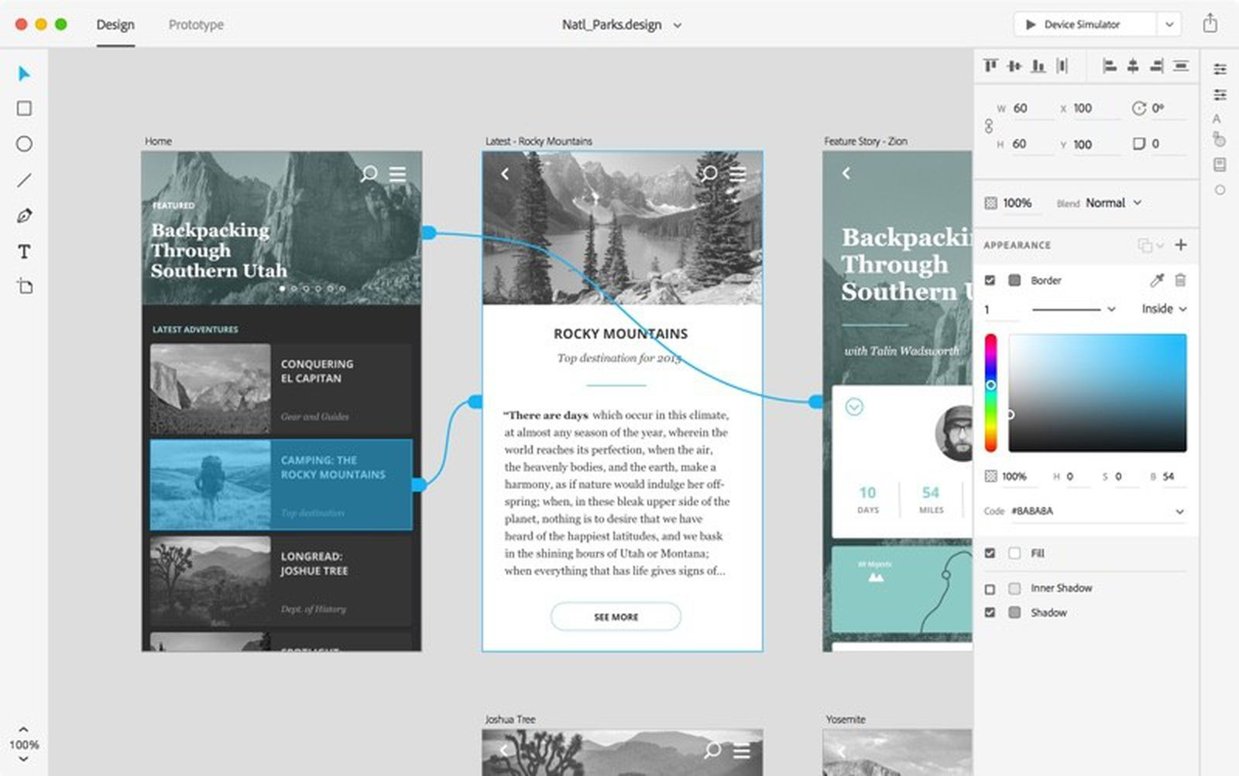

Figure 28: XD Interface

Based on the website (*What Is Adobe XD and What Is It Used For?* n.d.), a robust and user-friendly vector-based experience design platform, Adobe XD provides teams with the tools they need to jointly create the best experiences in the world. It provides designers with a well-liked design and prototyping tool, to make user interfaces, interactive prototypes, and user experiences. It has a number of benefits that make it a popular option for many design projects.

According to (*Adobe XD Review: Expanding Your Design Toolbox | Toptal®* n.d.), the strong prototyping features of Adobe XD are one of its main benefits. Designers can easily define interactions, transitions, and animations while creating interactive prototypes. Prior to moving on to the development phase, designers can gather feedback and make the required iterations by testing and validating their concepts using the built-in preview tool. By streamlining the design process, a more user-centric strategy is ensured.

A comprehensive collection of design features and tools are also available through Adobe XD. To maintain consistency throughout the project, designers can develop and alter UI elements, use different styling options, and manage design components. It supports various third-party plugins like Runner, Color Accessibility Check, Magic Mirror, Auto Animate, etc. Designers can also create adaptive designs that can scale across various screen sizes and devices thanks to the responsive resize function.

Adobe XD also excels in the area of collaboration. Designers can collaborate in real time and receive comments and feedback by sharing their design files with team members or stakeholders. Co-editing design files at the same time improves teamwork and speeds up the review and approval process.

Lastly, designers may access a variety of resources, including UI kits, icons, and plugins, through the active design community that Adobe XD offers. The design process is further improved by this community-driven environment, which fosters inspiration, knowledge sharing, and the exchange of design assets.

1. **Sketch**

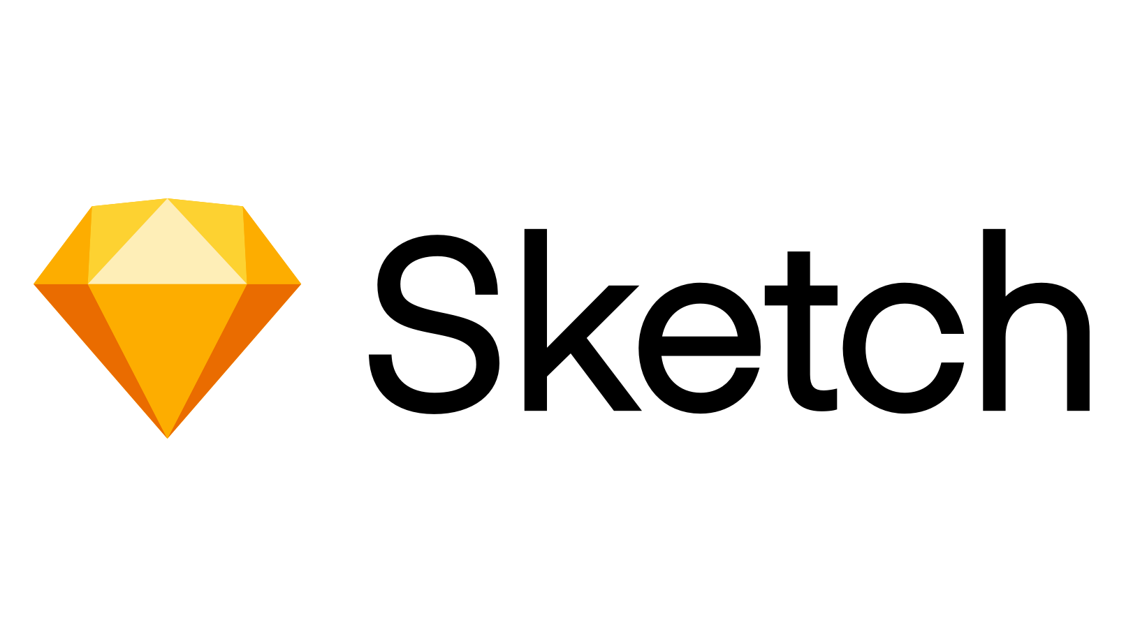

Figure 29: Sketch Logo

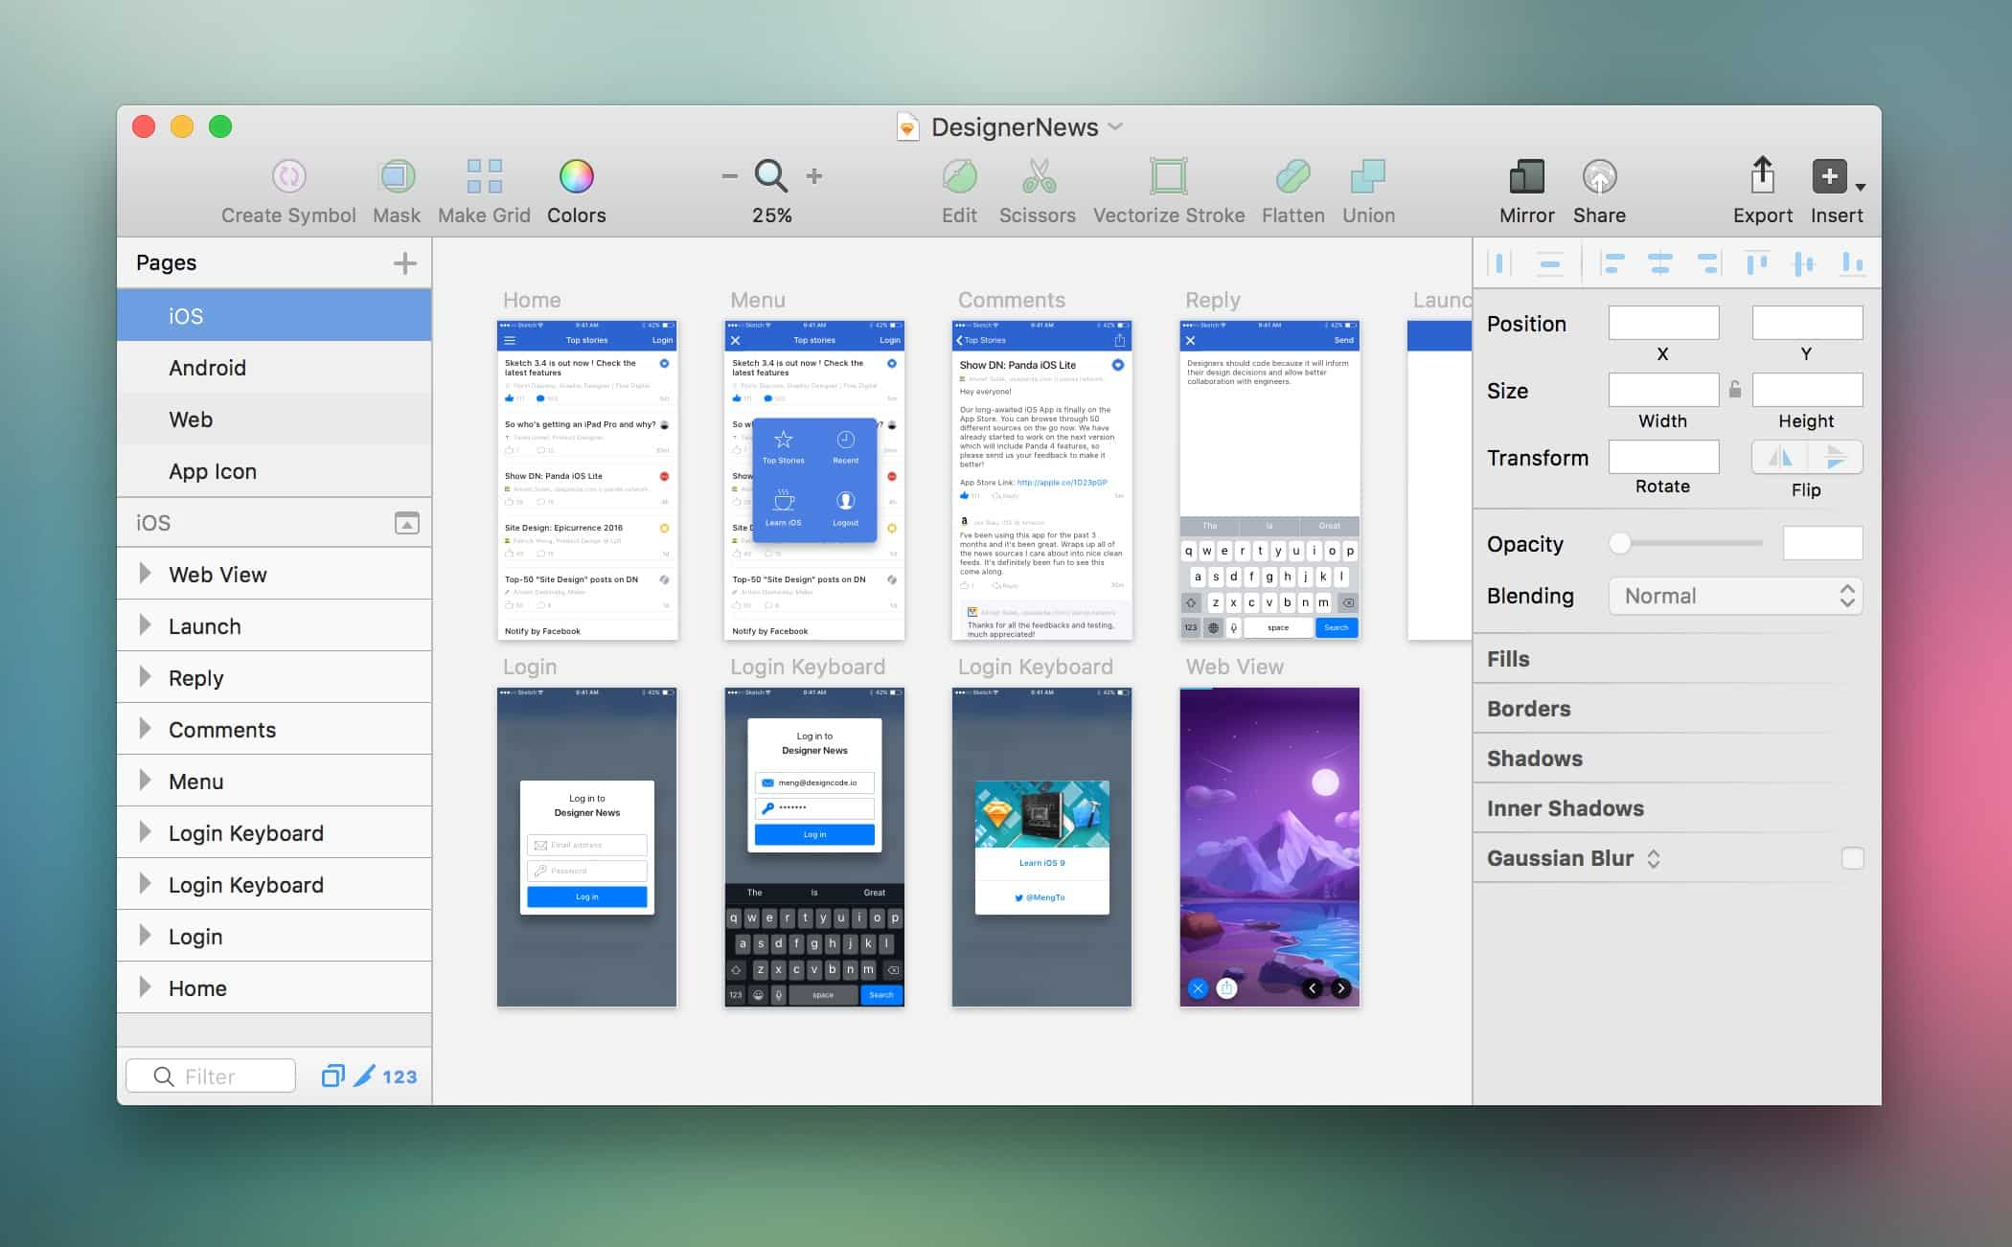

Figure 30: Sketch Interface

According to (*What Is Sketch and What Can You Do With It?* n.d.), Sketch is a vector graphics programme is called Sketch. It is a tool for product design that web designers frequently use to make idea pages, icons, and other online components. In addition, UI and UX designers love it a lot. Sketch offers a wide range of effective vector editing capabilities, as well as a variety of boolean operations, making it suitable for both amateur and professional artists. Non-Mac users can utilise the web app, and it has a native macOS app. The initial macOS version was launched in 2010, and a number of improvements have been made since then.

Referring to (*The Benefits of Using Sketch Designs in Software Development - Lightflows* n.d.), one of the key advantages of Sketch is its focus on user interface design. It offers a comprehensive collection of features and tools made especially for creating aesthetically pleasing and useful interfaces. Pixel-perfect designs are simple to make and may be precisely customised by designers.

The ability to edit vectors is another benefit of Sketch. With Sketch, designers can simply create scalable designs that can be easily resized without sacrificing quality. Sketch is based on a vector editing concept. This makes it perfect for creating flexible interfaces that can adjust to various screen sizes and resolutions while delivering a consistent user experience across devices.

A growing ecosystem of plugins and extensions is another advantage of Sketch. By incorporating different plugins, designers can improve their work processes and increase the capability of Sketch. These plugins give designers extra tools, templates, and automation features so they may speed up their design workflow, work more efficiently, and access a greater variety of design materials.

The collaborative capabilities of Sketch make collaboration simpler. Several designers can collaborate on the same design file at once, making changes in real time and exchanging feedback. This encourages teamwork and makes the design review process run more smoothly, resulting in effective communication and swift project advancement.

Despite being primarily a design tool, Sketch also has some basic prototyping features. To show user flow and interactions, designers might construct interactive prototypes with basic transitions and animations. Although Sketch's prototyping capabilities are less robust than those of specialised prototyping tools, it nonetheless offers designers a handy way to present their work and test interactions.

Last but not least, Sketch benefits from a vibrant design community that actively supports its development. By using UI kits, icon libraries, and other resources, designers may take advantage of the ecosystem that is generated by the community. They can take part in debates, learn from tutorials, and keep up with the most recent design trends, encouraging continual inspiration and learning.

|  |  |  |  |
| --- | --- | --- | --- |
| **Features** | **Figma** | **Adobe XD** | **Sketch** |
| Multi-platform support | Yes | Yes | No |
| Real-time collaboration | Yes | No | No |
| Prototyping | Yes | Yes | No |
| Robust vector editing | Yes | Yes | Yes |
| Plugins and integrations | Yes | Yes | Yes |
| Design components | Yes | Yes | Yes |
| Handoff and sharing | Yes | Yes | Yes |
| Ease of learning | Yes | Yes | No |
| Comprehensive vector editing tools | No | Yes | Yes |
| Prototyping built-in | No | Yes | No |

Table 4: Comparison of Figma, XD & Sketch

For this project, Figma is the recommended design tool because of its outstanding features and capabilities. Figma provides a complete solution for designing and refining project visuals with its multi-platform compatibility, real-time collaboration, and strong prototyping capabilities. Productivity and efficiency are increased by having the ability to work smoothly across various devices and collaborate with team members in real-time. The vast selection of plugins and connectors available for Figma further increases its usefulness and customization possibilities. Both novice and seasoned designers can utilise it thanks to its simple interface and user-friendly layout. A streamlined workflow is also made possible by Figma's vector editing tools, design elements, and ease of sharing and handoff of designs. In conclusion, Figma is the best option for this project due to its adaptability, collaborative tools, and user-friendly interface.

### **2.5.5 Comparison of SDLCs**

Figure 31: Waterfall Model

By studying the journal (Alshamrani and Bahattab n.d.), three types of waterfall models will be compared, waterfall, spiral and incremental models. The waterfall model is a linear and sequential approach to software development. Each phase, including requirements gathering, design, development, testing, deployment, and maintenance, is finished before moving on to the next in an organised process. The paradigm emphasises meticulous documentation, up-front planning, and tight adherence to predetermined protocols. This method functions effectively for projects with clear end goals from the beginning and requirements that are stable and well-defined. The Waterfall model, however, lacks flexibility and might make it difficult to take into account modifications or input after a phase is finished.

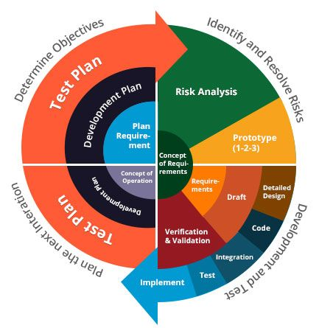

Figure 32: Spiral Model

On the other side, the Spiral model employs an iterative and risk-driven methodology. It incorporates aspects of both iterative development and the waterfall methodology. Through a series of rounds, the Spiral model focuses on early risk detection and mitigation. The planning, risk analysis, development, and assessment phases make up each iteration. The concept promotes regular consumer input and participation throughout the development process. Large, complicated projects with shifting requirements and a need for efficient risk management are particularly well-suited to this strategy. The Spiral model, however, necessitates ongoing monitoring and risk assessment, which could make projects more difficult.

Build 1

Build 2

Build 3

Figure 33: Incremental Model

The incremental model breaks the software development project up into smaller pieces, or modules, each of which offers a certain set of functions. This allows for the early delivery of viable software because the increments are produced and provided incrementally. It is possible to test and analyse each increment independently, giving room for immediate feedback and customization. The incremental model offers flexibility and allows for adjustments in response to client input and changing requirements. It is especially helpful for projects where user input is required and needs are expected to change frequently. To ensure integration and compatibility between increments, though, careful planning and collaboration are required.

|  |  |  |  |
| --- | --- | --- | --- |
| **Models** | **Waterfall** | **Spiral** | **Incremental** |
| Approach | Linear and sequential | Iterative and risk-driven | Iterative and incremental |
| Phases | Sequential phases (requirements, design, development, testing, deployment, maintenance) | Iterative cycles (planning, risk analysis, development, evaluation) | Iterative development in smaller increments |
| Requirements | Well-defined and stable | Evolving and may change over time | Evolving and may change over time |
| Flexibility | Limited flexibility for changes once a phase is completed | Accommodates changes throughout the process | Accommodates changes based on feedback |
| Risk Management | Not explicitly built-in | Emphasizes early risk identification and mitigation | Implicitly manages risk through iterations |
| Customer Involvement | Less involvement during development process | Frequent customer involvement and feedback | Frequent customer involvement and feedback |
| Delivery Time | Longer delivery time due to sequential nature | Iterative cycles may reduce overall delivery time | Early delivery of usable software |
| Complexity | Lower complexity due to predefined processes | Moderate complexity due to continuous risk assessment | Moderate complexity with coordination needs |
| Suitable For | Well-defined and stable requirements | Projects with changing requirements and risk management needs | Projects with evolving requirements |

Table 5: Comparisons of Waterfall, Spiral & Incremental Models

Due to its compliance with well-defined requirements, structured development methodology, emphasis on documentation, milestone-based progress monitoring, and obvious project deadline, the Waterfall model is quite ideal for the Groomify project. The Waterfall methodology offers a methodical and structured development process with Groomify's unique grooming and personal care functions. Complete documentation acts as a reference for upcoming maintenance and aids in sustaining project discipline. The writer can effectively create the app while concentrating on the specified goals, lowering the risk of scope creep, and delivering a high-quality final product by using the Waterfall approach.

## **2.6 Conclusion**

The pet grooming software will be created using Flutter, which enables cross-platform development for both Android and iOS devices, in accordance with the decisions made. Because of its scalability, real-time data synchronisation, and simple connection with other Firebase services, Firebase will be used as the database. Dart, a programming language renowned for its effectiveness and cutting-edge capabilities, was selected. Because of its bigger market share and simple app distribution, the software will primarily target users of the Android operating system.

Flutter, a framework, offers a thorough and effective development environment that makes it possible to design a visually beautiful and responsive user experience. The development process is sped up by its hot reload functionality, which allows developers to make real-time changes and immediately view the results. The construction of unique and interactive components is also possible thanks to the vast widget library offered by Flutter, which improves the user experience of the app.

The project will move through consecutive phases, such as requirements gathering, design, implementation, testing, and deployment, by employing a waterfall software development approach. This strategy offers a well-organized and structured process that makes sure each stage is finished before going on to the next. It enables extensive planning and documentation, lowering the risk of scope creep and guaranteeing a stable and trustworthy end result.

In conclusion, there are various benefits to using Flutter, Firebase, Dart, and the Android operating system for the pet grooming app project. Scalability, real-time data synchronisation, effective cross-platform development, and simple Firebase service integration are all made possible. Programming in Dart offers a contemporary and effective development environment. The larger user base and simple app distribution of the Android platform make it worthwhile to target it. A high-quality and user-friendly pet grooming app can be produced by using an agile SDLC because iterative development, regular feedback, and a shorter time to market are all advantages of the approach.

# **Chapter 3**

# **Research Methodology**

## **3.1 Introduction**

The Waterfall model is a well-known software development technique that includes requirements gathering, design, implementation, testing, and deployment among its sequential phases. Every stage builds on what came before it, ensuring a disciplined and orderly approach to development. Delivering the produced application to end users successfully is the main goal of the deployment phase. This calls for thorough preparation, coordination, and the use of suitable deployment technologies. The Flutter and Dart frameworks will be used for this project to support cross-platform development, enabling effective code sharing and quick development cycles. The usage of Figma as a collaborative design tool will make it possible to create interfaces that are both aesthetically pleasing and user-friendly. As a strong backend platform, Firebase will also enable smooth deployment, scalability, and performance monitoring by providing hosting, database, and analytics services. The project intends to provide a top-notch pet grooming application that meets the needs and expectations of its consumers by embracing the Waterfall paradigm and utilising these deployment methods.

## **3.2 SDLC**

Referring to Chapter 2 of the report, the Waterfall Model has been chosen as the Software Development Life Cycle (SDLC) approach. The Waterfall model, is a popular software development methodology renowned for its sequential and linear approach, was employed in the pet grooming app deployment process. The Waterfall model's phases all contributed significantly to the rigorous and organized development process that led to the app's successful release.

The requirements’ gathering phase is the first stage of the waterfall model. This stage involves extensive investigation and analysis to pinpoint and record the precise needs of the pet grooming software. This entails being aware of the requirements of pet owners, the intended features, and functionalities of the app, and any technical or regulatory limitations that must be taken into account. The requirements collecting phase ensures a comprehensive grasp of the project scope and objectives and lays the groundwork for the succeeding phases.

The design phase follows the collection and documentation of the requirements. The pet grooming app's overall architecture and organization are established during this phase. This comprises setting the database structure, developing the user interface, and producing wireframes and prototypes. The design phase is concerned with turning the specified requirements into a practical and aesthetically pleasing app that satisfies the expectations of the intended consumers.

The development phase starts after the design phase. Here is where the pet grooming app's actual development and execution happen. The Flutter framework and the selected programming language, Dart, are both used to create the app's functionality and features. To provide a reliable and effective app, the development phase adheres to design standards and best coding practices.

The testing phase starts once the development phase is over. To find and fix any flaws or difficulties with the software, this step entails a variety of testing tasks. In order to verify the app's functionality, performance, and user experience, many testing techniques, including unit testing, integration testing, and user acceptability testing, are used. Before being made available to users, the testing step makes sure the pet grooming software satisfies quality requirements and performs as planned.

The pet grooming app is finally made available to the target consumers during the distribution phase. This include putting together the app's packaging, gathering the necessary materials, and submitting it to the appropriate app stores for release. To ensure the app's ongoing functionality and user happiness, the deployment phase also entails managing updates and maintenance.

The pet grooming app project benefits from a well-structured and systematic approach to development by using the Waterfall model in the research technique. The Waterfall model's sequential structure allows for careful planning, documenting, and quality assurance at every stage. It encourages a clear knowledge of the project requirements, lowers the chance of scope creep, and makes sure the finished software satisfies the desired objectives and user expectations.

The Waterfall approach may, however, be constrained in terms of adaptability and flexibility. Making major changes without returning to prior phases might be difficult once a phase is over and the project goes on. To reduce the need for large changes later in the development process, it is necessary to undertake a thorough analysis and acquire correct requirements up front.

## **3.3 Deployment Tools**

The requirements gathering phase was the first stage of the waterfall model. To fully grasp the needs and specifications of the pet grooming software, a significant amount of research and analysis were done during this phase. A thorough list of functional and non-functional criteria was established through interviews, surveys, and interactions with stakeholders like pet owners and service providers. The following stages of the development process were built on top of these criteria.



The system design process started when the requirements were precisely outlined. In this step, the specified requirements were turned into a thorough system design. It involved building wireframes or interactive prototypes to visualize the user interface as well as designing the app's architecture and database structure. Figma will be utilized, as described in Chapter 2, to streamline the design process, enabling collaborative design reviews and iterative improvements based on the writer's experience in UI/UX designing.

 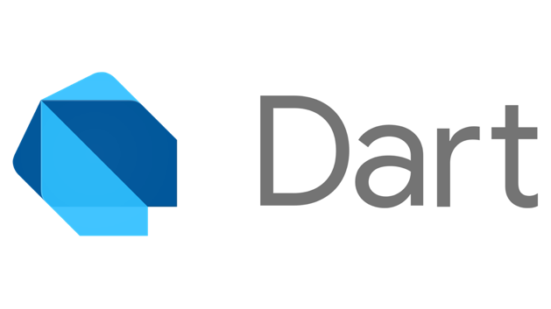

The Implementation phase started after the Design phase. During this stage, the pet grooming app was coded and developed. The Dart framework and the selected programming language, Flutter, gave the app's features and functionalities a strong base. To guarantee the dependability and maintainability of the code, the development team adhered to industry standards, used version control systems, and followed best practises for coding.

The Testing phase gained prominence as the Implementation phase moved forward. To find and fix any flaws or problems with the app's operation, performance, and usability, thorough testing was done. To ensure that the software complied with the requirements, several testing methodologies, including unit testing, integration testing, and user acceptability testing, will be used. To ensure a high-quality and stable program, bugs and glitches must be quickly fixed through several rounds of testing.



Once the testing phase was successfully completed, the app proceeds to the Deployment phase. The app must be released and made accessible to end users at this phase. With its scalable and secure backend infrastructure for hosting the app's data and controlling user authentication, Firebase played a significant part in this phase. Additionally, the seamless deployment of the app to Android users through the Google Play Store was made possible using Firebase's app distribution capabilities. However, the deployment phase is not included in the project's objectives because development is its exclusive focus.

The discrete phases and linear progression of the waterfall model enabled a methodical and regulated approach to the pet grooming app's implementation. The development team managed project timeframes, scope, and deliverables well by adhering to this paradigm. The distinct division of the processes enabled thorough planning, careful design, meticulous development, thorough testing, and successful app release. Overall, the use of the Waterfall model helped the pet grooming software be successfully implemented and meet the needs of pet owners and pet groomers in a dependable and effective way.

## **3.4 Conclusion**

In conclusion, the pet grooming software was created using an organised process based on the Waterfall model, including stages like requirement gathering, system design, implementation, testing, and delivery. The programming language and framework used were Flutter and Dart, ensuring quick development and cross-platform interoperability. The user interface of the app was significantly influenced by Figma, and Firebase supplied a solid backend architecture. The software was created specifically for the Android operating system with a broad user base in mind. The development portion of the app was successfully finished thanks to thorough planning and adherence to the Waterfall paradigm throughout the process.

## **References**

1. *Adobe XD Review: Expanding Your Design Toolbox | Toptal®* (n.d.) available from <https://www.toptal.com/designers/adobe/adobe-xd-review> [21 June 2023]
2. Alshamrani, A. and Bahattab, A. (n.d.) *A Comparison Between Three SDLC Models Waterfall Model, Spiral Model, and Incremental/Iterative Model*. [online] available from <www.IJCSI.org> [11 June 2023]
3. *Android Development with Kotlin - Marcin Moskala, Igor Wojda - Google Books* (n.d.) available from <https://books.google.com.my/books?hl=en&lr=&id=PJZGDwAAQBAJ&oi=fnd&pg=PP1&dq=kotlin&ots=3KkhfzPYyD&sig=3KiKFsX_rRfGH9fzfTB0bUb-H24&redir_esc=y#v=onepage&q=kotlin&f=false> [15 June 2023]
4. *Benefits of Pet Grooming Software in the Pet Industry | Meetbrandwide* (n.d.) available from <https://meetbrandwide.com/blog/2022/06/22/benefits-of-pet-grooming-software-in-the-pet-industry/> [9 May 2023]
5. *Designing and Prototyping Interfaces with Figma: Learn Essential UX/UI ... - Fabio Staiano - Google Books* (n.d.) available from <https://books.google.com.my/books?hl=en&lr=&id=GOBeEAAAQBAJ&oi=fnd&pg=PP1&dq=comparison+of+figma,+xd+and+sketch&ots=ekfwnM8O5M&sig=IGOn9ydUAFVYkIT72AOkenO7UaI&redir_esc=y#v=onepage&q&f=false> [21 June 2023]
6. *Flutter for Beginners: An Introductory Guide to Building Cross-Platform ... - Alessandro Biessek - Google Books* (n.d.) available from <https://books.google.com.my/books?hl=en&lr=&id=pF6vDwAAQBAJ&oi=fnd&pg=PP1&dq=dart+flutter&ots=dYOVVE0v9s&sig=_FVlEO07Rlqt7-mH_JJXqixwgHc&redir_esc=y#v=onepage&q=dart%20flutter&f=false> [15 June 2023]
7. Fox, L. (2022) *Booking.Com on Mobile App Usage, Consumer Trends | PhocusWire* [online] available from <https://www.phocuswire.com/booking-CMO-Arjan-Dijk-mobile> [5 May 2023]
8. *Kotlin in Action - Dmitry Jemerov, Svetlana Isakova - Google Books* (n.d.) available from <https://books.google.com.my/books?hl=en&lr=&id=OzkzEAAAQBAJ&oi=fnd&pg=PT16&dq=advantages+of+kotlin&ots=F10DqvmkMk&sig=T003i2RSK3C7UYSeyASEJbrwArY&redir_esc=y#v=onepage&q=advantages%20of%20kotlin&f=false> [15 June 2023]
9. *MongoDB in Action: Covers MongoDB Version 3.0 - Kyle Banker, Douglas Garrett, Peter Bakkum, Shaun Verch - Google Books* (n.d.) available from <https://books.google.com.my/books?hl=en&lr=&id=kzkzEAAAQBAJ&oi=fnd&pg=PT21&dq=mongodb&ots=8U8ZuU3166&sig=_-p2wY2w82-CV2dq0RY61Hdl6rQ&redir_esc=y#v=onepage&q=mongodb&f=false> [15 June 2023]
10. *MySQL - Paul DuBois - Google Books* (n.d.) available from <https://books.google.com.my/books?hl=en&lr=&id=cCiA8HsQhGUC&oi=fnd&pg=PT36&dq=mysql+database&ots=Tv225T2-Wf&sig=muM2VQ83Iyw_ln3lZOBlWw7phMU&redir_esc=y#v=onepage&q=mysql%20database&f=false> [15 June 2023]
11. *Programming Android - Zigurd Mednieks - Google Books* (n.d.) available from <https://books.google.com.my/books?hl=en&lr=&id=QP7VvnhDOOsC&oi=fnd&pg=PR3&dq=java+for+android+development&ots=Z0x1Q_RlqH&sig=nr1mYmX4l-_7QemBTQclj3aT3-M&redir_esc=y#v=onepage&q=java%20for%20android%20development&f=false> [15 June 2023]
12. *Sci-Hub | Beginning App Development with Flutter | 10.1007/978-1-4842-5181-2* (n.d.) available from <https://sci-hub.se/https://link.springer.com/book/10.1007/978-1-4842-5181-2> [15 June 2023]
13. *The Benefits of Using Sketch Designs in Software Development - Lightflows* (n.d.) available from <https://www.lightflows.co.uk/blog/the-benefits-of-using-sketch-designs-in-software-development/> [21 June 2023]
14. *The Definitive Guide to Firebase* (2017) [online] available from <https://doi.org/10.1007/978-1-4842-2943-9> [15 June 2023]
15. *What Is Adobe XD and What Is It Used For?* (n.d.) available from <https://www.adobe.com/products/xd/learn/get-started/what-is-adobe-xd-used-for.html> [21 June 2023]
16. *What Is Sketch and What Can You Do With It?* (n.d.) available from <https://www.makeuseof.com/what-is-sketch/> [21 June 2023]
17. Wukkadada, B., Nambiar, R., Nair, A., Professor, A., and Somaiya, K.J. (2015) ‘Mobile Operating System: Analysis and Comparison of Android and IOS’. *IJCAT-International Journal of Computing and Technology* [online] 2 (7). available from <www.IJCAT.org> [21 June 2023]